PARTS CATALOG
Pik Rite, Inc
60 Pik Rite Lane
Lewisburg, PA 17837
Ph. 800-326-9763
Fx. 570-523-8175
www.pikrite.com

April 27, 2015

HYDRA-RAM 1880 VB PUSH
MANURE SPREADER


1880 VB HYDRA-RAM MANURE SPREADER

HYDRA-RAM 1880VB PUSH MANURE SPREADER

(SPECIFICATIONS AND DESIGN SUBJECT TO CHANGE WITHOUT NOTICE)

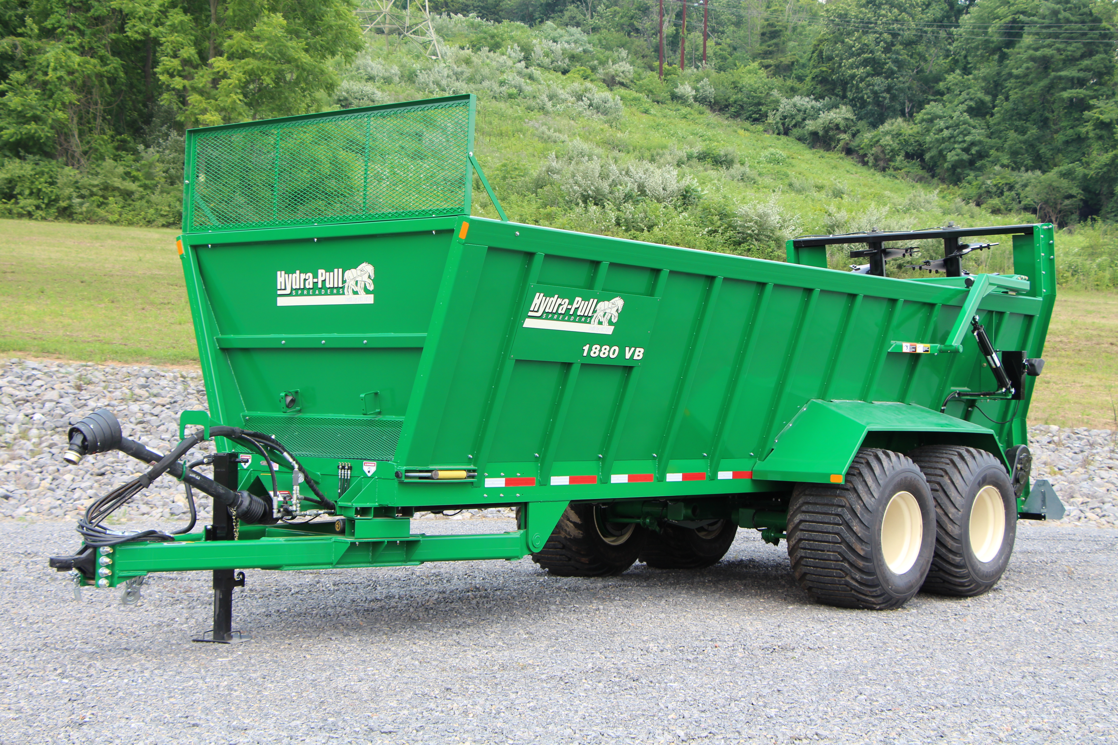

DIRECTION ARROW

ARROWS ARE USED WITH ILLUSTRATIONS TO INDICATE THE FRONT OF THE UNIT. “RIGHT-HAND” AND “LEFT-HAND” SIDES ARE DETERMINED BY FACING THE DIRECTION OF MACHINE FORWARD TRAVEL.

BOX ENCLOSED ILLUSTRATIONS

A REFERENCE NUMBER, SHOWN IN THE PARTS LIST, IS ASSIGNED TO A BOX ENCOMPASSING ALL PARTS SOLD AS A SERVICE ASSEMBLY.

REFERENCE NUMBER IDENTIFICATION

000-099 PARTS USED FOR ASSEMBLY
  - BOLTS & FASTENERS
800-899 REPLACEMENT PARTS OR SERVICE ASSEMBLIES – USED TO REPLACE OR REBUILD COMPONENTS OF THE MACHINE

TABLE OF CONTENTS

7514-01-01 Main Frame & Floor 8
7514-01-02 Front Shields 10
7514-01-03 Sliding Floor 12
7514-01-04 Moving Panel 14
7514-01-05 Endgate 16
7514-01-06 Axle & Walking Beam 18
7514-01-07 Wheels & Tires 20
7514-01-08 Optional - Weight Scale Assembly, 5 Point System 22
7514-02-01 1000 RPM Drive Line 24
7514-02-04 Main Drive Shaft 28
7514-02-05 Vertical Beater 30
7514-02-05A Vertical Beater Gearbox 33
7514-03-01 Hydraulics, Push Off Cylinders 36
7514-03-02 Hydraulics, Endgate Clylinders 38
7514-03-03 Cylinders, Sliding Floor 40
7514-03-04 Cylinders, Main Pusher Cylinder 42
7514-03-05 Cylinder, Secondary Pusher 44
7514-03-06 Cylinder, Endgate 46
7514-03-07 Hydraulic, Sequence Valve w/ Flow Control 48
7514-04-01 Air Brakes 50
7514-04-02 Hydraulic Brakes 54
7514-05-01 Electrical & Lighting 56
7514-05-02 Safety Tow Chain 58
7514-05-03 Jack Stand 60
7514-05-04 SMV Emblem & Brackets 62
7514-06-01 Decals, Front of Spreader 64
7514-06-02 Decals, Side & Rear 66
7514-01-01 Main Frame & Floor
PARTS
CATALOG
Ref | Part No. | Description | Parts – Assembly | Will Fit SN | Remarks

1 | PR80000 | Main Frame, 1880 VB X | 1

2 | PR60022 | Fender, LH, 880 Bushel Spreader | 1

3 | PR60023 | Bracket, LH, End Gate Mount | 1

4 | PR60024 | Bracket, RH, End Gate Mount, 880 Bushel Spreader | 1

5 | PR60036 | Fender, RH, 1880 Spreader | 1

6 | PR60043 | Decal Plate, Angled, Side | 2

7 | PR80007 | Load Cell Mount, Hitch Area, 1880 VB | 1

8 | PR80008 | Delete Load Cell, 1880 VB | 1

9 | PR80009 | Floor, End | 1

10 | PR80019 | Floor, Mid, Tongue and Groove | 9

11 | TH-0002 | Bull-Pull Articulating Hitch, 3-Bolt | 1

12 | MF-9304 | 24' X 36' Mudflap, w/ Logo (pc) | 2

23 | PR63101 | Hitch Shaft, w/ Guard | 1

100 | BL-16-550-H8 | 1' x 5 1/2', HH C/S G8 ZC | 1

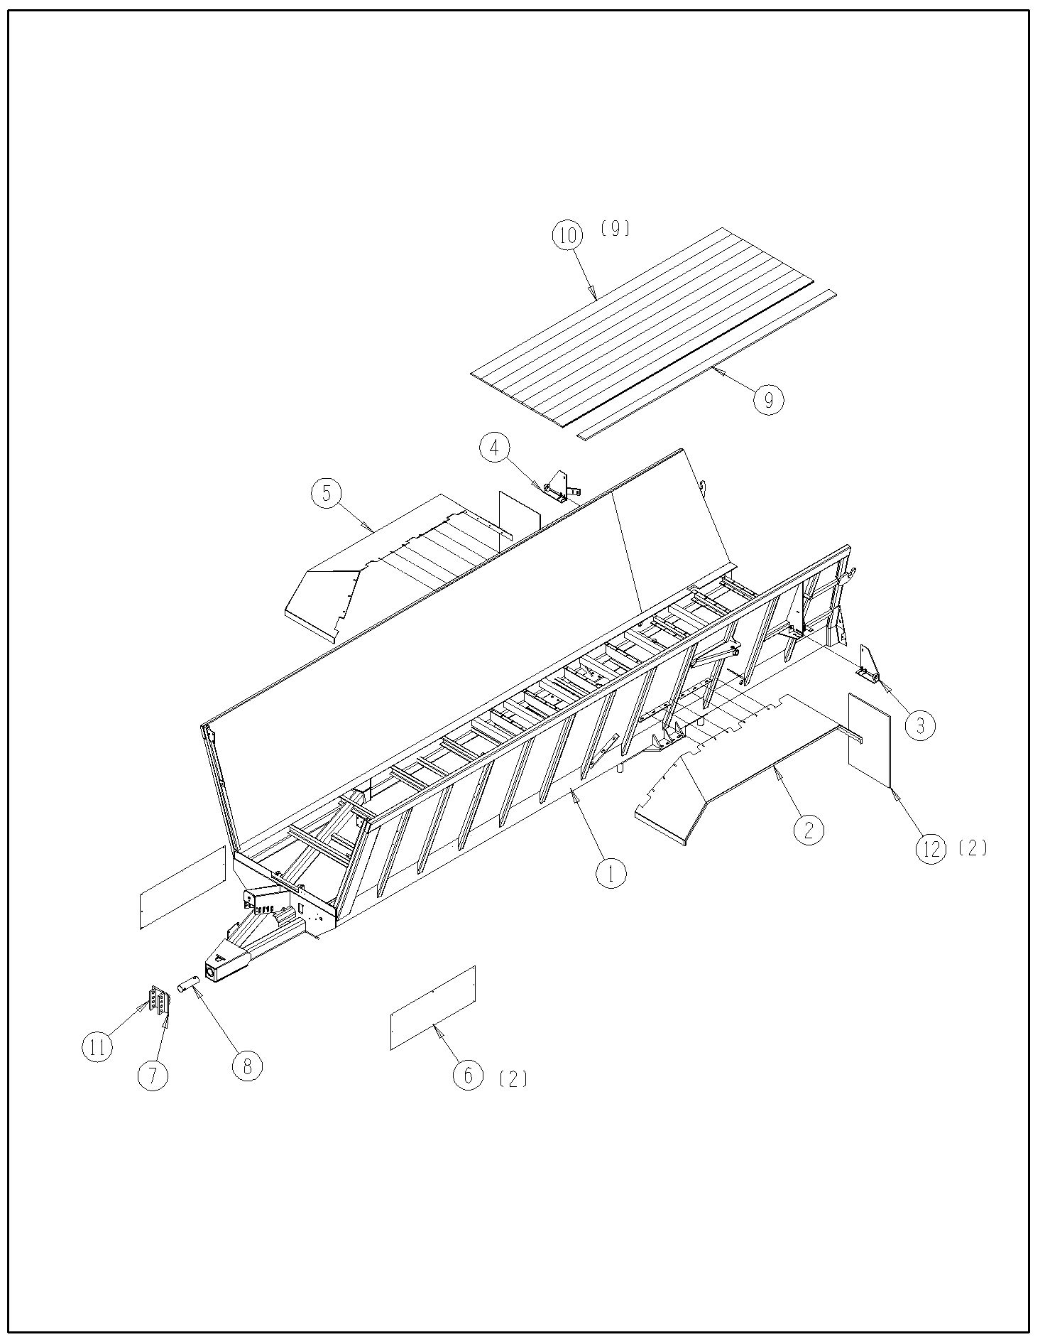
7514-01-01

7514-01-02 Front Shields
Ref | Part No. | Description | Parts – Assembly | Will Fit SN | Remarks

1 | PR80072 | PTO Holder | 1

2 | PR80204 | Front Panel | 1

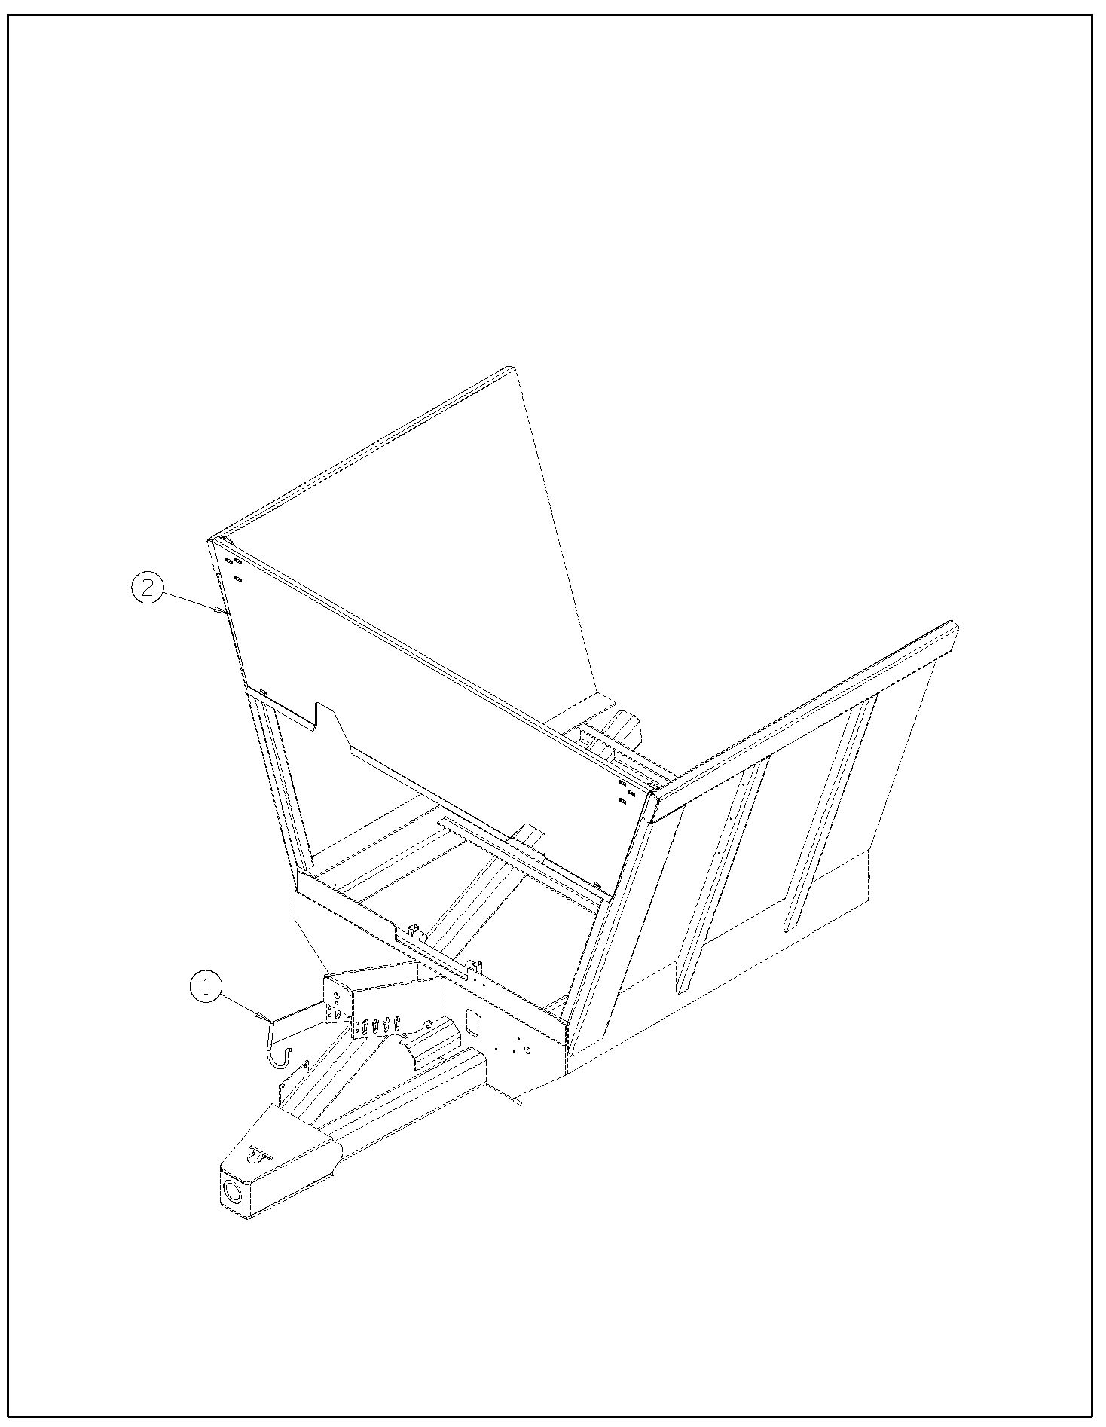
7514-01-02

7514-01-03 Sliding Floor
Ref | Part No. | Description | Parts – Assembly | Will Fit SN | Remarks

1 | PR80014 | Floor, Sliding Floor | 10

2 | PR80040 | Scraper, RH, sliding floor, 1880 | 1

3 | PR80041 | Scraper, LH, Sliding floor, 1880 | 1

4 | PR80042 | Belting Scraper, slinding floor, 1880 | 2

5 | PR80100 | Sliding Floor | 1

6 | PR80101 | Main Cylinder Stop | 1

7 | PR80102 | Cylinder Pin, Main Cylinder, Sliding Floor | 1

8 | PR80103 | Cylinder Pin | 1

9 | PR80104 | Spacer Slider Block | 6

10 | PR80105 | Side Spacer, Sliding Floor | 4

11 | PR80106 | Bottom Slider | 4

13 | PR80015 | Sliding Floor, End | 1

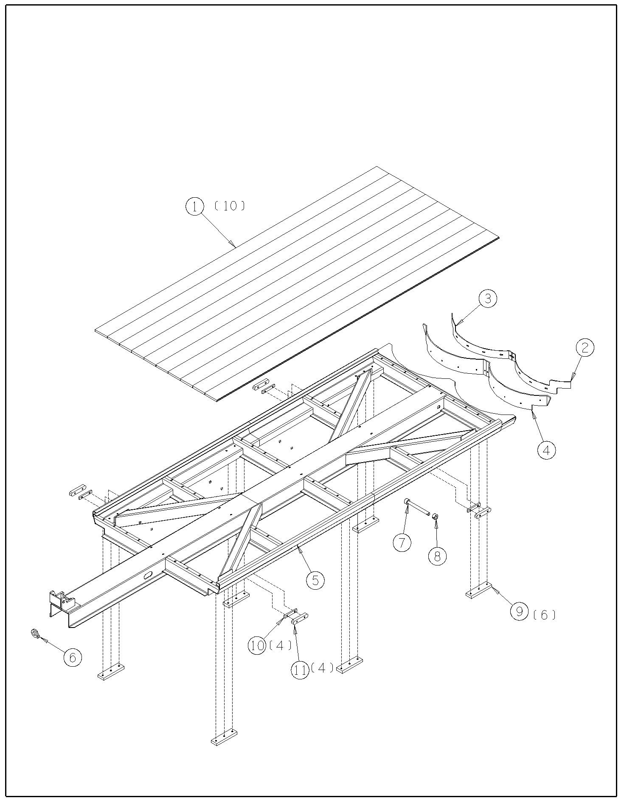
7514-01-03

7514-01-04 Moving Panel
Ref | Part No. | Description | Parts – Assembly | Will Fit SN | Remarks

1 | PR80020 | Pusher | 1

2 | PR80021 | First Sliding Section, Pusher | 1

3 | PR80021-F | Plate Steel | 1

4 | PR80022 | Scraper, Pusher | 2

5 | PR80023 | Backing Bar, Pusher | 1

6 | PR80024 | Backing Bar, Pusher | 1

7 | PR80025 | Belting, Pusher Side | 2

8 | PR80026 | Backing Bar, Pusher | 2

9 | PR80078 | First Push Spacer,White UHMW | 1

10 | PR80029 | Panel, Pusher, 1880 Push | 1

7514-01-05 Endgate
Ref | Part No. | Description | Parts – Assembly | Will Fit SN | Remarks

1 | PR80047 | End Gate | 1

2 | PR80048 | End Gate, Lift Arm, RH | 1

3 | PR80049 | End Gate, Lift Arm, LH | 1

4 | PR80050 | Belting, End Gate | 2

5 | PR80051 | Backing Bar, End Gate | 2

7 | PR80077 | Stop Adjuster, Endgate | 2

8 | PR80011 | Belting, End Gate Flap, Spreader | 1

9 | PR60012 | Flat Bar, Backing, End Gate Flap, Spreader | 1

10 | PR80013 | Bottom Belting, End Gate | 1

11 | PR80028 | Flat Bar, Bottom Endgate, 1880VB | 1

12 | PR60015 | End Gate Pin | 2

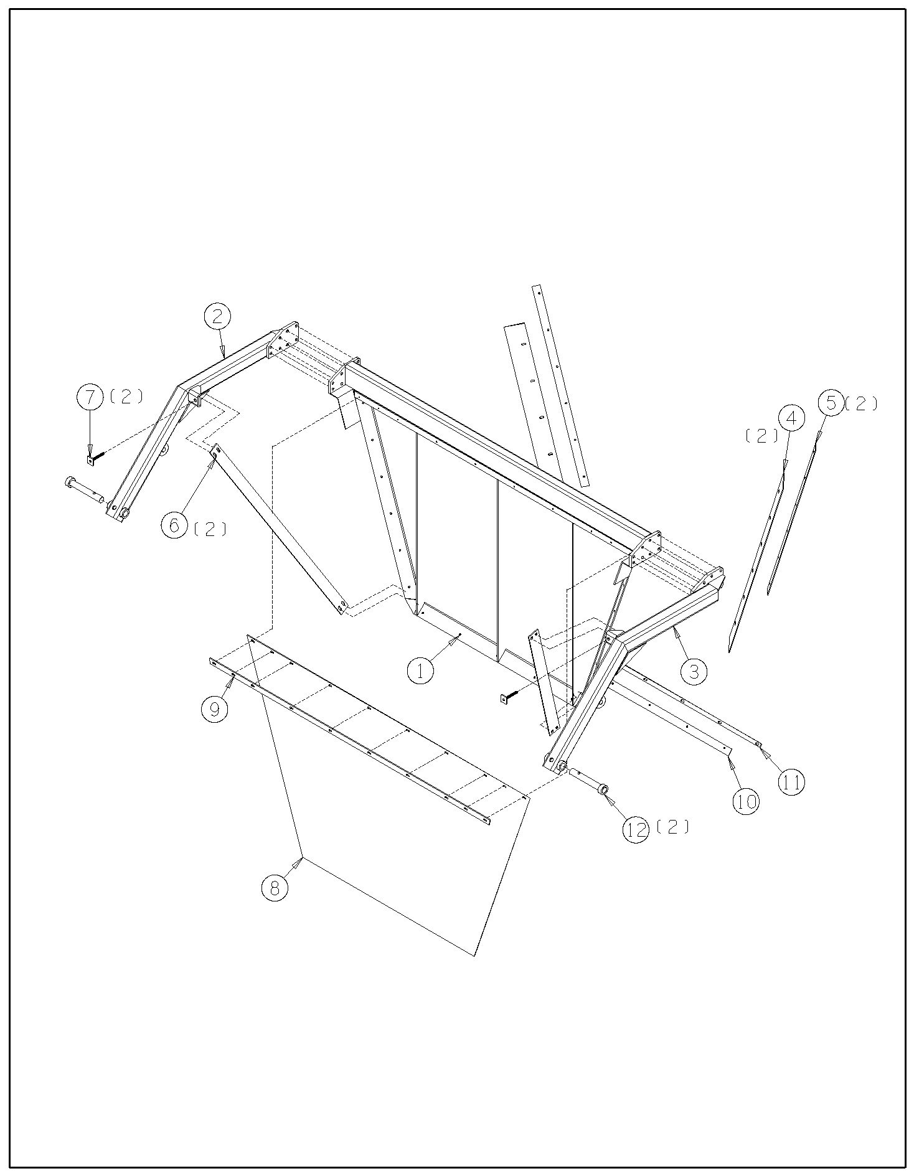
7514-01-05

7514-01-06 Axle & Walking Beam
Ref | Part No. | Description | Parts – Assembly | Will Fit SN | Remarks

1 | PR80004 | Rocker, Walking Beam | 2

2 | PR60003 | Shaft, Walking Beam Pivot, 880 Bushel Spreader | 2

3 | TRL-2750-2 | Dust Cover, For 27,000lb Axles | 4

4 | GF-2-2 | 2' Grease Manifold | 2

5 | PR80001 | Axle Frame | 1

601 | H2-76-2MP-2MP | 1/8 in grease hose 1/8MP x 1/8MP x 76 in long | 4

800 | TRL-2750-1-02 | Assy Hub 10 Stud 285.75mm | 1 |  | Special Order Only

801 | TRL-2750-1-03 | Inner Bearing Cup | 1 |  | Special Order Only

802 | TRL-2750-1-04 | Outer Bearing Cup | 1 |  | Special Order Only

803 | TRL-2750-1-05 | Stud, Press-in M22 x 1.5 | 10 |  | Special Order Only

804 | TRL-2750-1-06 | Drum, 16 ｽ' x 7' | 1 |  | Special Order Only

805 | TRL-2750-1-07 | Swivel Flange Nut | 10 |  | Special Order Only

806 | TRL-2750-1-08 | Gasket, Oil Cap | 1 |  | Special Order Only

807 | TRL-2750-1-09 | Oil Cap (with Vent Plug) | 1 |  | Special Order Only

808 | TRL-2750-1-10 | Lockwasher, Oil Cap | 6 |  | Special Order Only

809 | TRL-2750-1-11 | Cap Screw, Oil Cap | 6 |  | Special Order Only

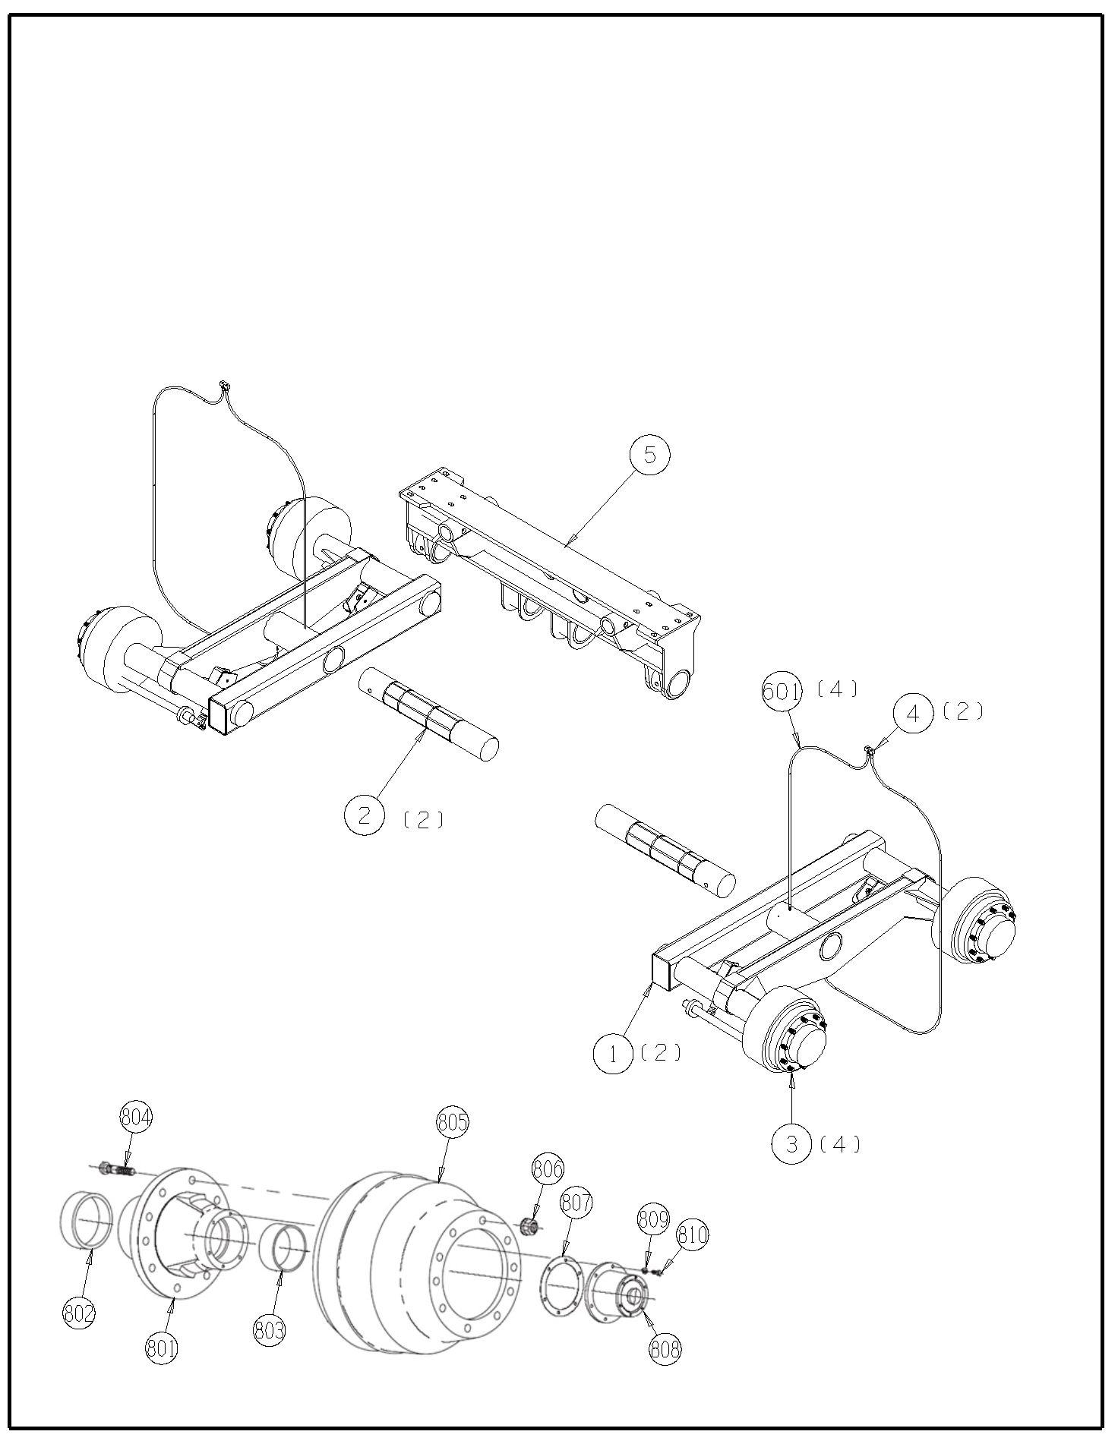
7514-01-06

7514-01-07 Wheels & Tires
Ref | Part No. | Description | Parts – Assembly | Will Fit SN | Remarks

1 | WHM-2000 | 700/40-22.5 Mounted Assembly | 4

801 | WHL-2000 | 10 X 285.75mm Bolt 24 x 22.5 | 1

802 | WHT-2000 | 700/40-22.5 328 Tread 18 Ply | 1

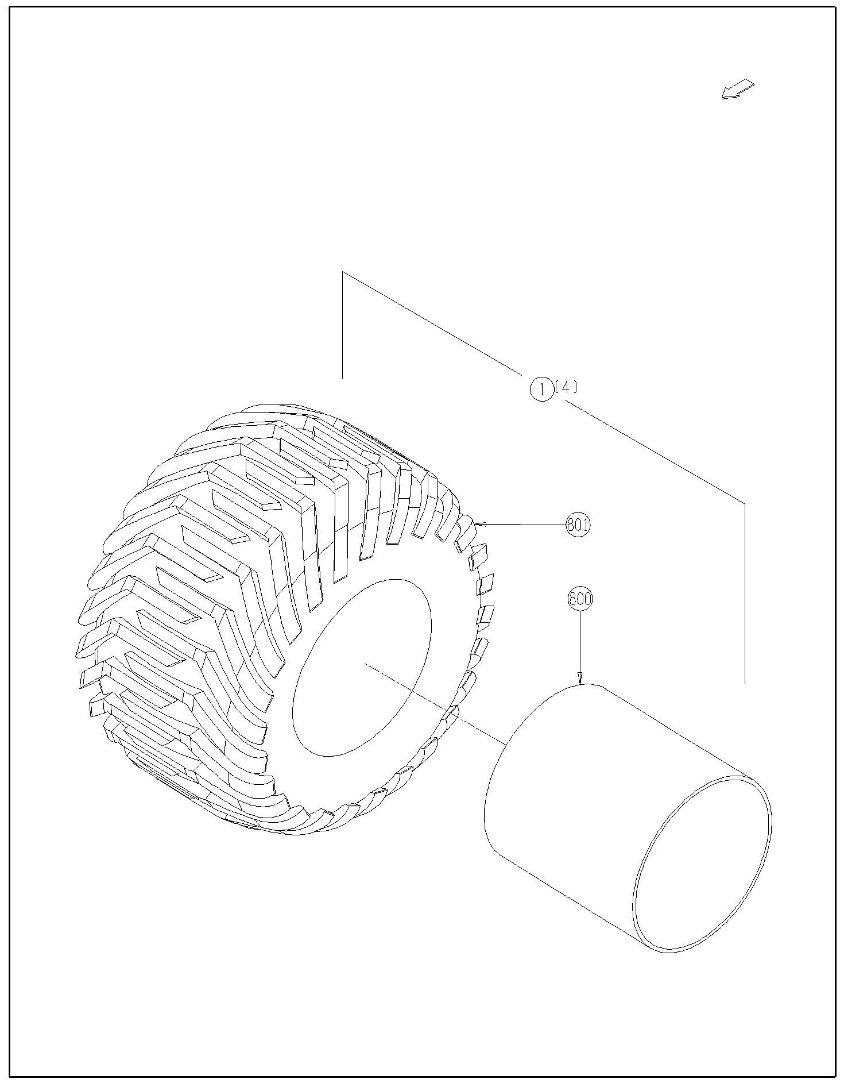
7514-01-07

7514-01-08 Optional - Weight Scale Assembly, 5 Point System
Ref | Part No. | Description | Parts – Assembly | Will Fit SN | Remarks

1 | PR80003 | Mount, Load Cell, 1880VB | 4

2 | PR80008 | Delete Load Cell, 1880 VB | -1

800 | SWS-4605 | Spreader Weighing system, 5 point Scale system with GT400 | 1

801 | SWS-4605-001 | Cell, dia 2.875 DB -21 | 0

802 | SWS-4605-002 | Cell, dia 2.875 DB-21 HT | 0

803 | SWS-4605-003 | J-Box 6 Pt | 0

804 | SWS-4605-004 | J Box Cable, 9m | 0

805 | SWS-4605-005 | Power Cable 4- wire, 3m Cable | 0

806 | SWS-4605-006 | GT400 Indicator with RS232 | 0

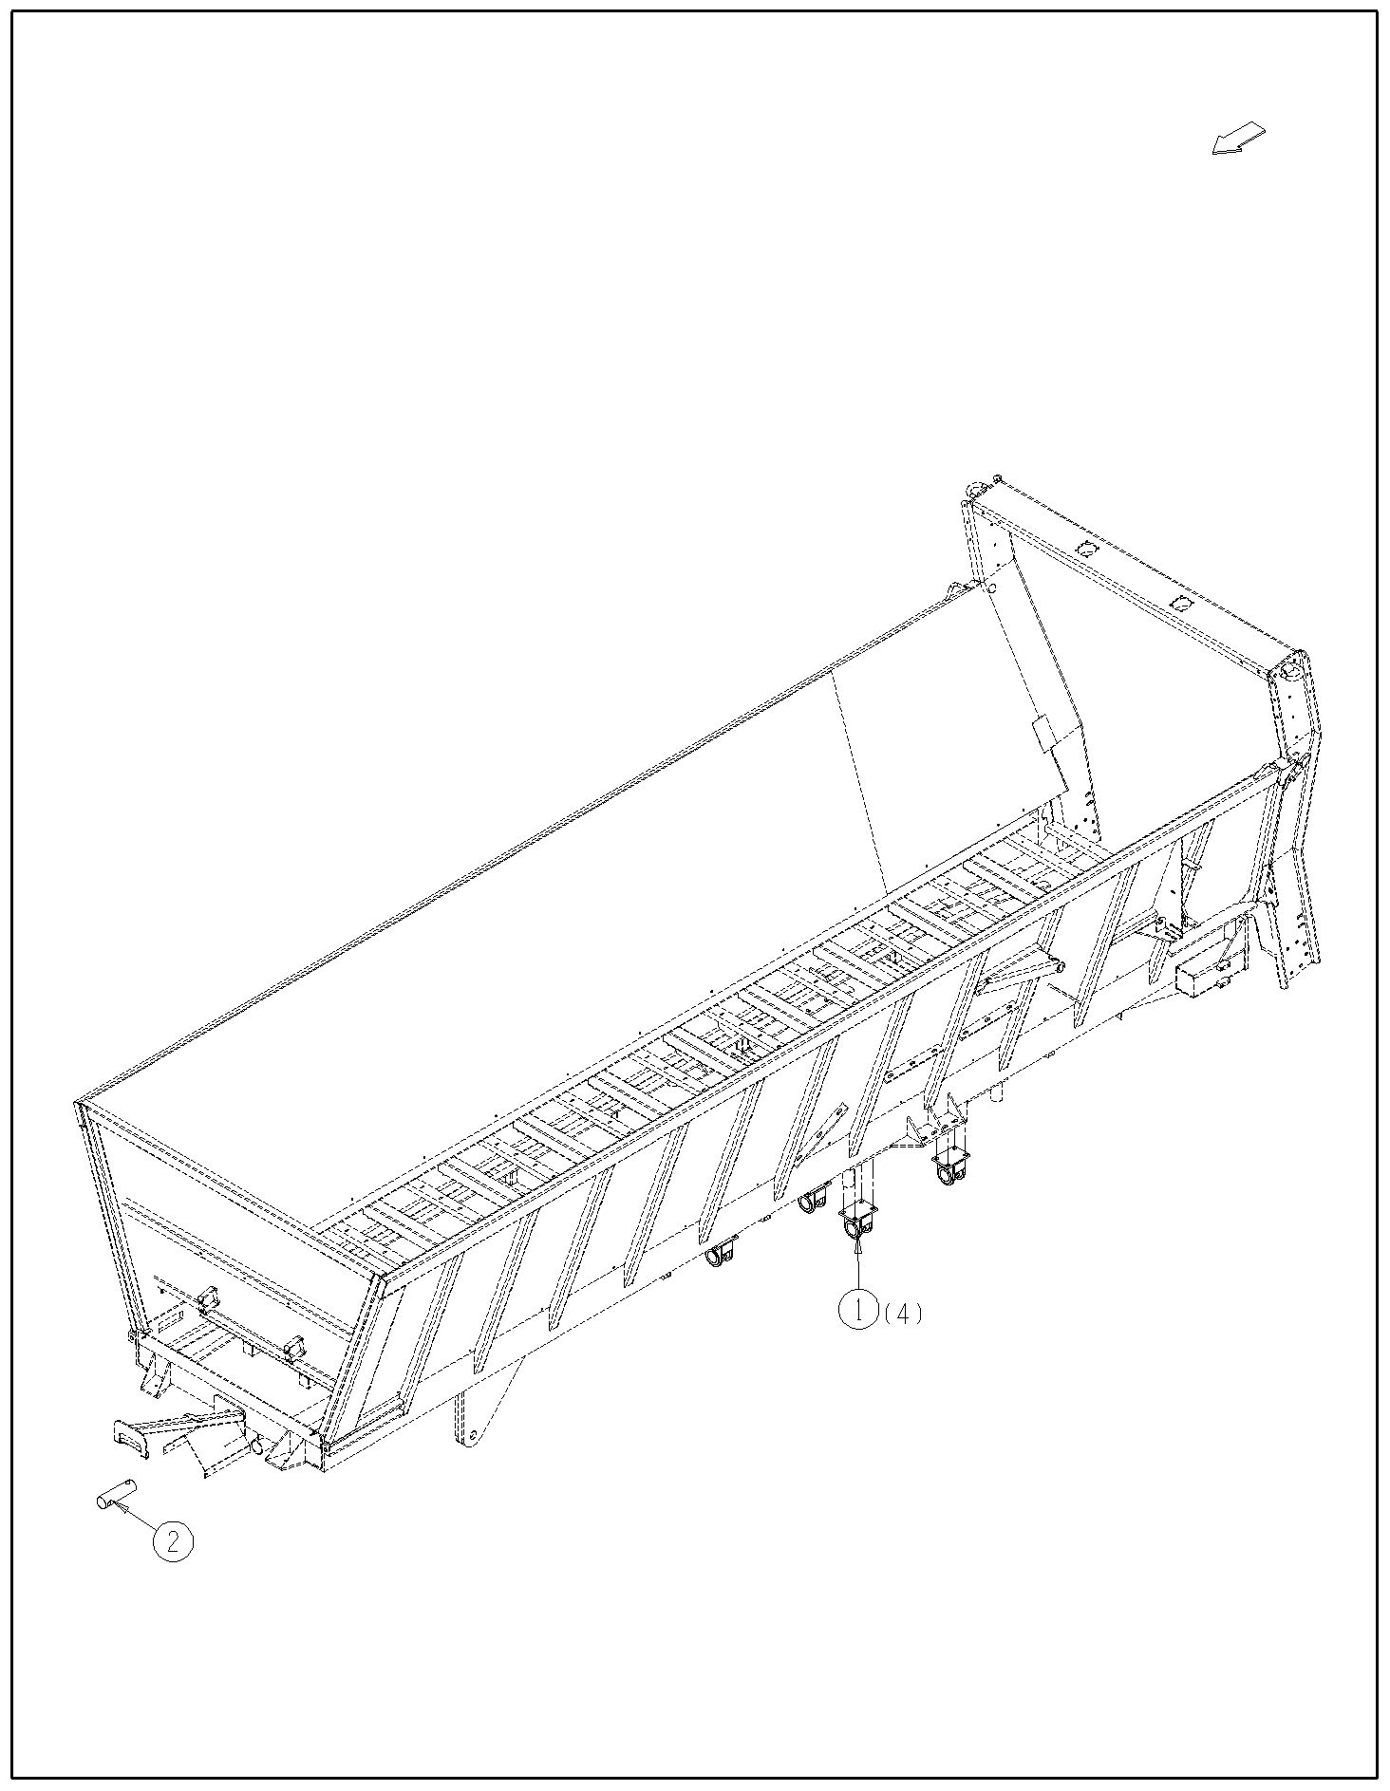
7514-01-08

7514-02-01 1000 RPM Drive Line
Ref | Part No. | Description | Parts – Assembly | Will Fit SN | Remarks

1 | PTS-1021 | Driveline,1-3/4-20 Spline, PWE580 HD Shaft For 880 Bushel Spreader | 1 |  | Replaces PTS-1020

801 | PTS-1008J | Yoke, 1 3/4'-20 Spline | 1 |  | Special Order Only

802 | PTS-1008C | Zerk, Double Yoke | 1 |  | Special Order Only

803 | PTS-1008B | Double Yoke | 1 |  | Special Order Only

804 | PTS-1008H | Inboard Yoke, 2a | 1 |  | Special Order Only

805 | PTS-1008E | Cross & Bearing Kit | 1 |  | Special Order Only

806 | PTB-1014C | Spring Pin 10 X 75 | 1 |  | Special Order Only

807 | PTS-1008P | Cross Bearing & Kit | 1 |  | Special Order Only

808 | PTS-1020E | Profile and Sleeve, WA-2aGL | 1 |  | Special Order Only

809 | PTS-1020A | Overrunning Clutch & 1bGA Profile Assy | 1 |  | Special Order Only

811 | PTS-1009L | Cut-Out Clutch | 1 |  | Special Order Only

820 | PTS-1010M | Decal, Inner | 1 |  | Special Order Only

821 | PTS-1010K | Screw | 5 |  | Special Order Only

823 | PTB-1014L | Zerk | 1 |  | Special Order Only

825 | PTS-1009J | Decal | 1 |  | Special Order Only

826 | PTS-1010B | Cross & Bearing Kit | 1 |  | Special Order Only

828 | PTS-1008R | ASG Collar Kit | 1 |  | Special Order Only

829 | PTS-1009K | CC Lock Assembly | 1 |  | Special Order Only

830 | PTS-1020FH | Front (Tractor) Half Shaft | 1 |  | Special Order Only

831 | PTS-1020RH | Rear (Implement) Half Shaft | 1 |  | Special Order Only

851 | PTS-1020A-A | Clutch Housing | 1 |  | Special Order Only

852 | PTS-1010F-E | Hub | 1 |  | Special Order Only

853 | PTS-1010F-A | Key | 2 |  | Special Order Only

854 | PTS-1010F-B | Leaf Spring | 2 |  | Special Order Only

855 | PTS-1010F-F | Supporting Ring | 1 |  | Special Order Only

856 | PTS-1010F-G | Retaining Ring | 1 |  | Special Order Only

857 | PTS-1020A-B | Profile, 1bGA | 1 |  | Special Order Only

858 | PTS-1010F-J | Spring Pin | 1 |  | Special Order Only

860 | PTS-1010F-H | Bearing Ring | 1 |  | Special Order Only

870 | PTS-1020-FS | Front Shield Kit | 1 |  | Special Order Only

880 | PTS-1020-RS | Rear Shield Kit | 1 |  | Special Order Only

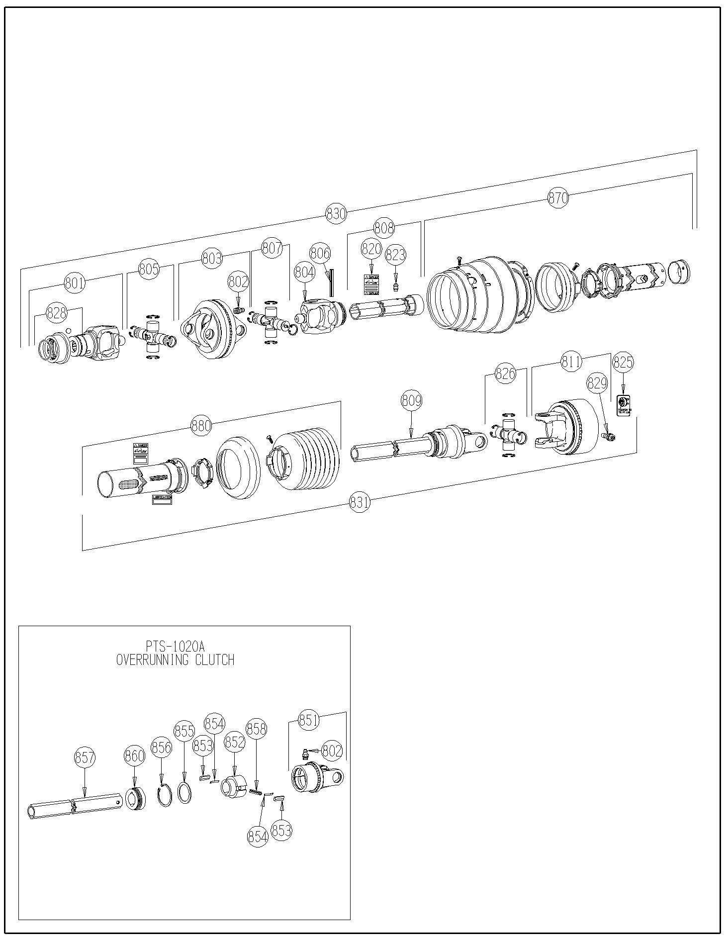
7514-02-01

7514-02-01

7514-02-04 Main Drive Shaft
Ref | Part No. | Description | Parts – Assembly | Will Fit SN | Remarks

1 | BR-175-100 | Heavy Duty I ｾ' Bearing | 6

2 | BR-100-RAK | Bearing Housing 100 mm | 6 | 11001

3 | PTS-1018 | Yoke Assembly 1-3/4-20 1Slip,1 Lock | 1

4 | PTS-1019 | Yoke Assembly, 1-3/4-20,1-3/4-6 Both Lock | 1

5 | PR60401 | Rear Drive Shaft, 880 Bushel Spreader | 1

6 | PR60402 | Main Drive Shaft, 880 Bushel Spreader | 2

7 | PR60404 | Coupler, 1.75 x 20 Spline, 12/24 Pitch, P.A. 30ｰ | 1

8 | PIN-4-36 | Roll Pin 1/4' x 2.25' | 1

601 | GF-4-4 | 4' Grease Manifold | 2

602 | GF-1827-45 | Grease Fitting 1/8 NPT 45ｰ | 7

603 | A-1404-4-4 | 1/4 MP x 1/4 FPX | 9

604 | GFA-51942 | 1/4'-28 Straight Adapter | 12

604 | GFA-51943 | 1/4'-28 90ｰ Adapter | 5

606 | GFA-43716 | 1/8', 45ｰ Adapter | 1

607 | GFA-310912 | 1/4'-28 45ｰ Adapter | 4

608 | CL-6-3 | Clamp, 3/8' O.D., Dual Tube, 1/4' Bolt Mount | 3

609 | GF-3-3 | 3' Grease Manifold | 1

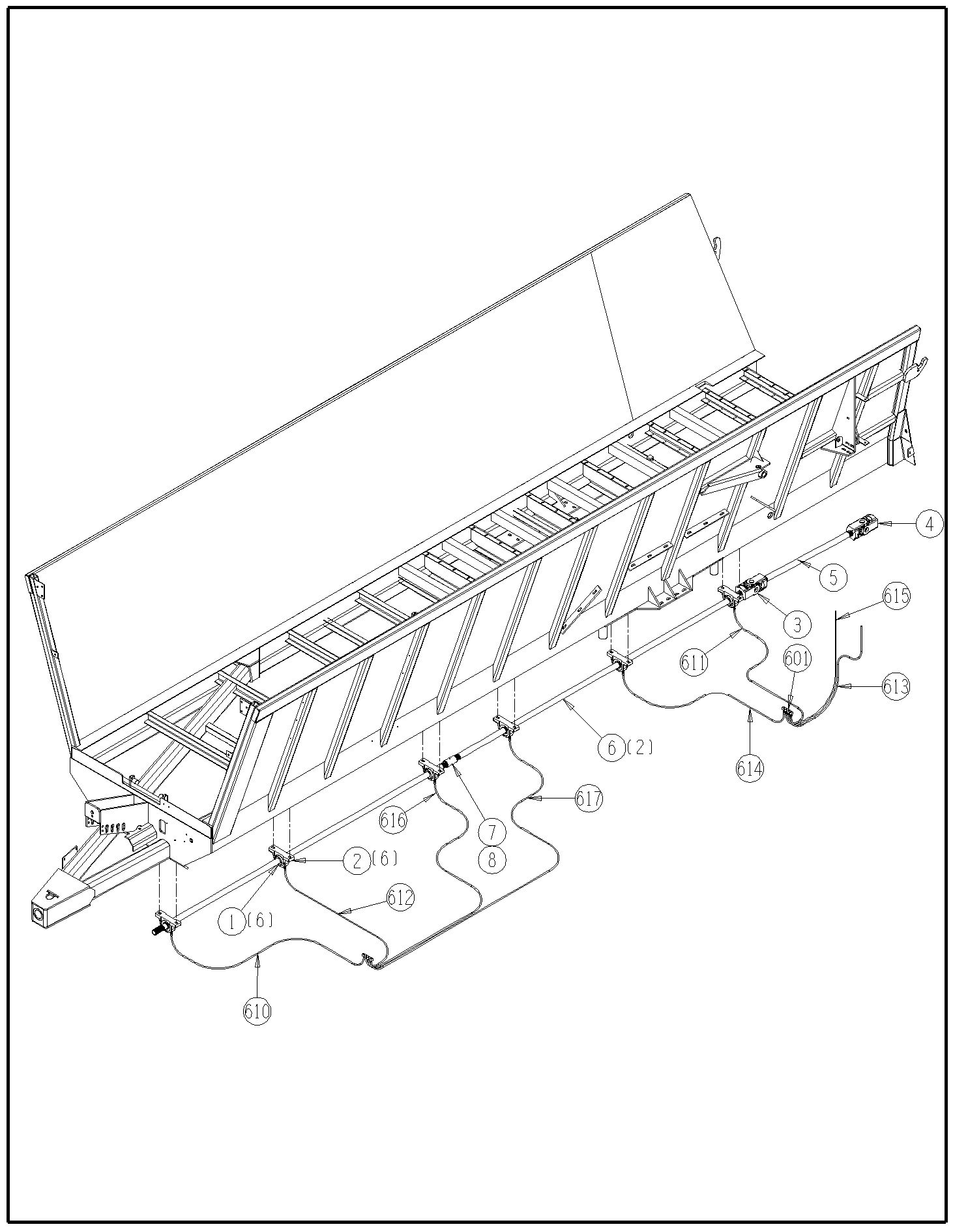
7514-02-05 Vertical Beater
7514-02-04

Ref | Part No. | Description | Parts – Assembly | Will Fit SN | Remarks

0 | HP-1038 | Gear Lube, 80W90 @ Quart | 11 | Hydra Ram Spreader

1 | PR80052 | Vertical Beater Frame, LH | 1

2 | PR80053 | Beater Pan, Main Frame Mounted | 1

3 | PR80054 | Beater Pan, Vertical Beater Assy | 1

4 | PR80055 | Plate, Top Bearing, Vertical Beater | 1

5 | PR80056 | Top Beater Panel, Vertical Beater | 1

6 | PR80057 | Vertical Beater Frame, RH | 1

7 | VTB-0022 | Vertical Beater, LH, 1880 Push | 1

8 | VTB-0023 | Vertical Beater, RH, 1880 Push | 1

9 | VTB-1893-A1 | 1000 RPM Beater Gearbox, 1880 Spreader | 1

10 | VTB-1899-A3 | Knife | 0 | 1880: -74015014

11 | VTB-1899-B3 | Right Blade | 13

12 | VTB-1899-C3 | Left Blade | 13

13 | VTB-1899-F3 | Knife, Weight Specific | 60 | 1190VB: 71113001-  1180VB: 74015011-

14 | GF-2-2 | 2' Grease Manifold | 1

15 | BR-085-4PF | 85mm Four Bolt Piloted Flange Housing | 2

16 | BR-175-085-I | Bearing, 1 ｾ' ID, TS | 2

101 | BL-10-175-H8 | 5/8-11 X 1 ｾ HEX CAP G8 ZC | 164

102 | BL-10-200-H | 5/8-11 X 2 HEX CAP G5 ZC | 4

103 | BL-10-200-H8 | 5/8-11 X 2 HEX CAP G8 ZC | 12

104 | BL-10-LNS | 5/8-11 Stover Lock Nut | 180

105 | BL-10-SW | 5/8 SAE FW ZC @ | 8

106 | BL-7-125-HH | 7/16' x 1 1/4', Hex Head, Gr 5, Zinc | 8

107 | BL-7-LW | 7/16' Split LW,Zinc Coated | 8

108 | BL-7-SW | 7/16 SAE FW ZC | 8

109 | BL-9-200-H8 | 9/16-12 x 2, Hex Head, Grade 8 | 16

110 | BL-9-FW-8 | 9/16' Grade 8 Flat Washer | 16

111 | BL-9-LN | 9/16' Lock Nuts w/Nylon Inserts | 16

602 | A-1404-4-4 | 1/4 MP x 1/4 FPX | 2

604 | H2-143-2MP-2MP | 1/8 in grease hose 1/8MP x 1/8MP x 143 in long | 1

605 | H2-174-2MP-2MP | 1/8 in grease hose 1/8MP x 1/8MP x 174 in long | 1

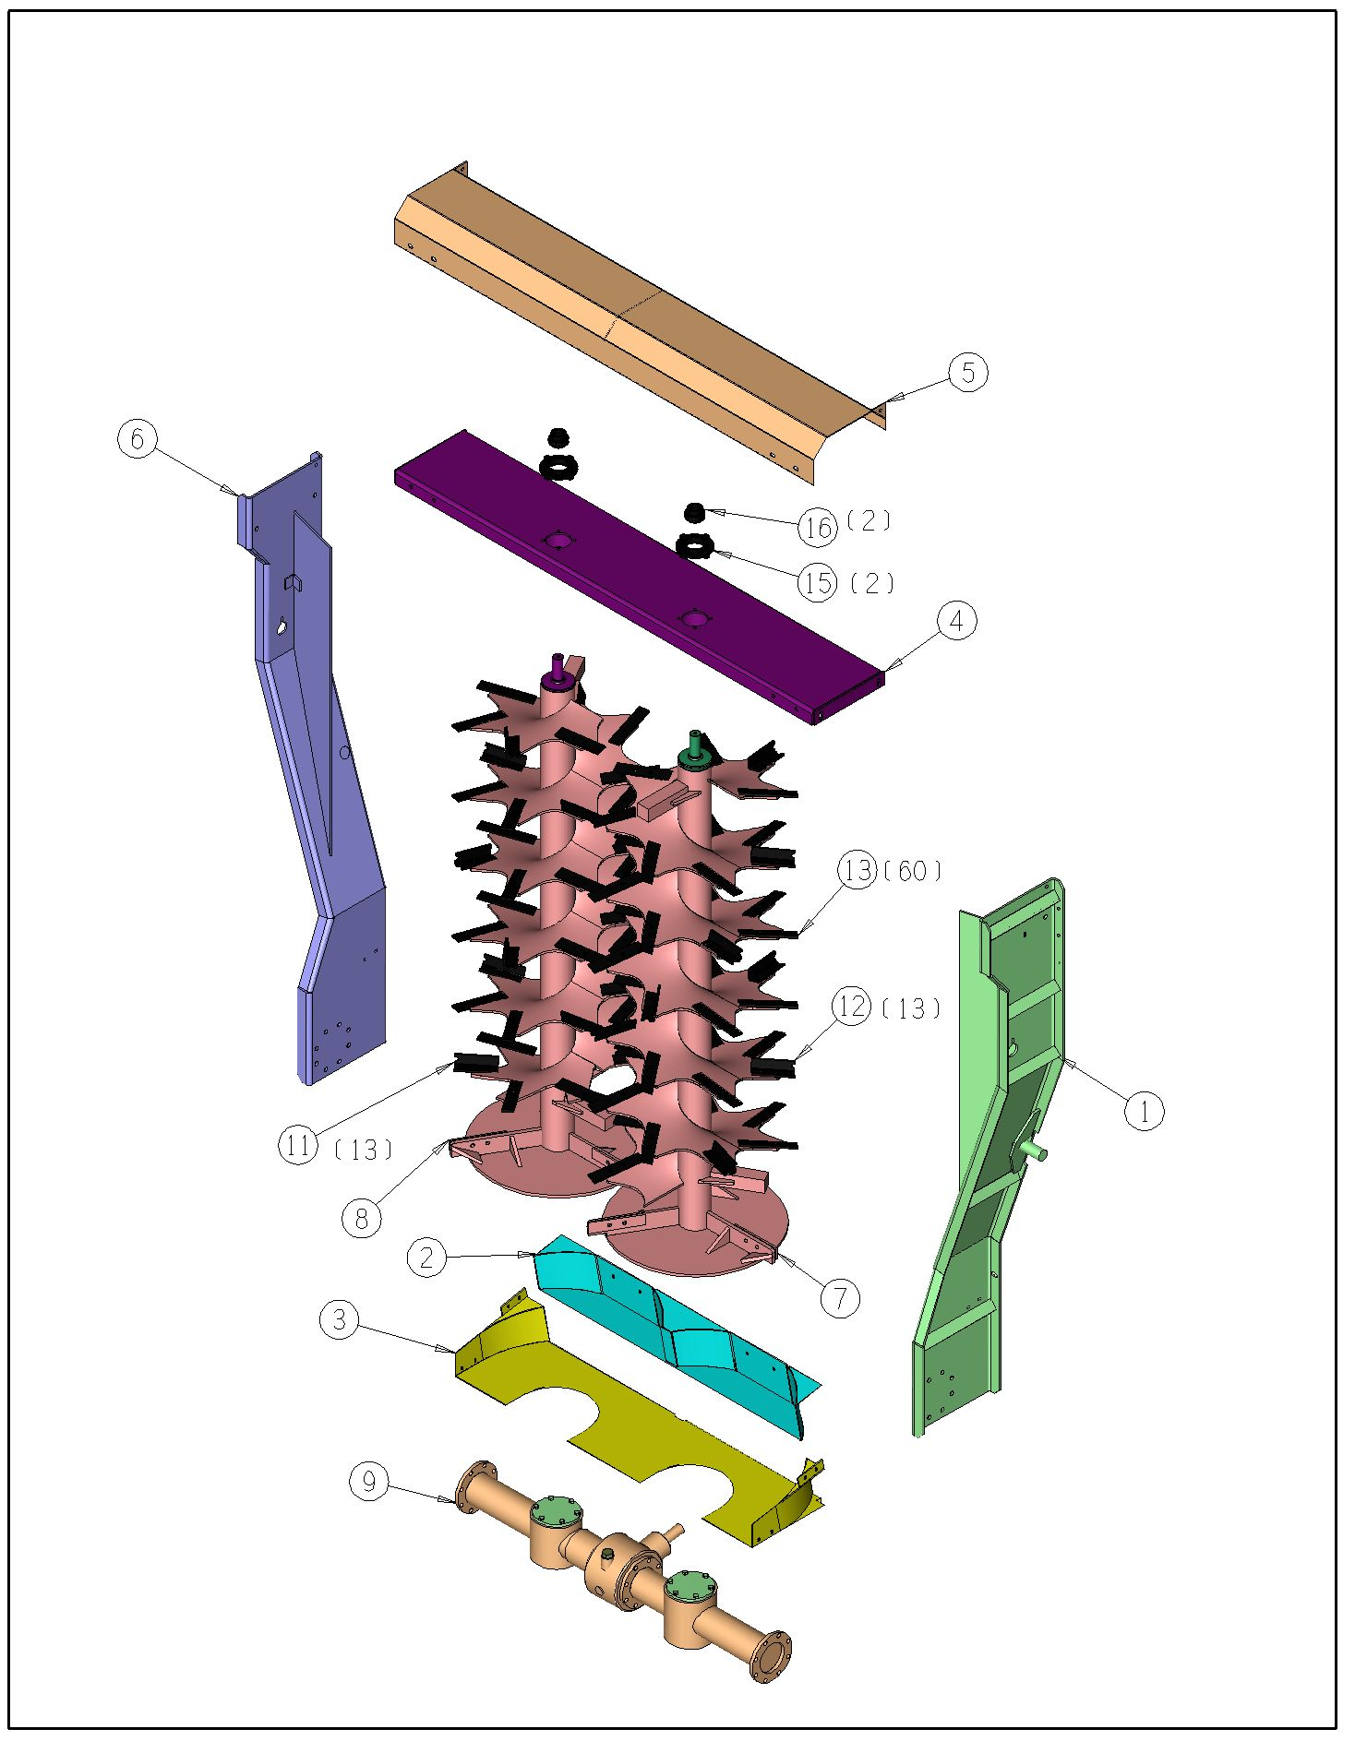
7514-02-05A Vertical Beater Gearbox
Ref | Part No. | Description | Parts – Assembly | Will Fit SN | Remarks

1 | VTB-1893-A1 | 1000 RPM Beater Gearbox, 1880 Spreader | 1

801 | VTB-1899-A1 | Housing | 1 |  | Special Order Only

802 | VTB-1899-J2 | Hub | 1 |  | Special Order Only

803 | VTB-1899-H2 | Gasket | 1 |  | Special Order Only

804 | VTB-1899-G1 | Bearing 32209 | 4 |  | Special Order Only

805 | VTB-1899-L2 | Shaft | 1 |  | Special Order Only

806 | VTB-1899-D1 | Threaded Ring | 2 |  | Special Order Only

807 | VTB-1899-E1 | Washer | 3 |  | Special Order Only

808 | VTB-1899-K2 | Oil Seal | 1 |  | Special Order Only

809 | VTB-1893-B1 | Right Spacer Tube | 1 |  | Special Order Only

810 | VTB-1899-A2 | Gasket | 2 |  | Special Order Only

811 | VTB-1893-C1 | Snap Ring | 1 |  | Special Order Only

812 | VTB-1899-H1 | Bearing 6311 | 1 |  | Special Order Only

813 | VTB-1893-D1 | Spined Shaft | 2 |  | Special Order Only

814 | VTB-1899-V1 | Spacer | 2 |  | Special Order Only

815 | VTB-1899-W1 | Gear Z=22 | 2 |  | Special Order Only

816 | VTB-1899-X1 | Bearing 32210 | 2 |  | Special Order Only

817 | VTB-1899-T1 | Bearing 6311-2RS | 2 |  | Special Order Only

818 | VTB-1899-M1 | Spacer | 2 |  | Special Order Only

819 | VTB-1899-Q1 | Calotte | 2 |  | Special Order Only

820 | VTB-1899-S1 | Oil Seal | 2 |  | Special Order Only

821 | VTB-1899-R1 | Gasket | 2 |  | Special Order Only

822 | VTB-1893-E1 | Snap Ring | 2 |  | Special Order Only

823 | VTB-1893-F1 | Right Spacer Tube | 1 |  | Special Order Only

824 | VTB-1899-C1 | Shaft | 1 |  | Special Order Only

825 | VTB-1899-F1 | Bevel Pinion Z=13 | 2 |  | Special Order Only

826 | VTB-1899-K1 | Circlip E 55 | 1 |  | Special Order Only

827 | VTB-1899-L1 | Threaded Ring | 1 |  | Special Order Only

828 | VTB-1893-G1 | End Cap | 2 |  | Special Order Only

829 | VTB-1899-E2 | Oil Plug, 1' Gas. | 1 |  | Special Order Only

830 | VTB-1899-Y1 | Spacer L=428 | 1 |  | Special Order Only

831 | VTB-1899-D2 | Oil Plug, 1/2' Gas | 1 |  | Special Order Only

832 | VTB-1899-Z1 | Screw, hex-hd M14X35 | 22 |  | Reference Only, Special Order

833 | VTB-1899-P1 | Screw, hex-hd M14X30 | 12 |  | Reference Only, Special Order

834 | VTB-1899-N1 | O-ring 2212 | 2 |  | Special Order Only

835 | VTB-1899-G2 | Bevel Pinion Z=17 | 1 |  | Special Order Only

836 | VTB-1899-J1 | Gear Z=24 | 1 |  | Special Order Only

837 | VTB-1893-H1 | Cap | 2 |  | Special Order Only

838 | VTB-1899-M2 | Hub Complete, 790, 1190VB Gearbox | 1 |  | Special Order Only
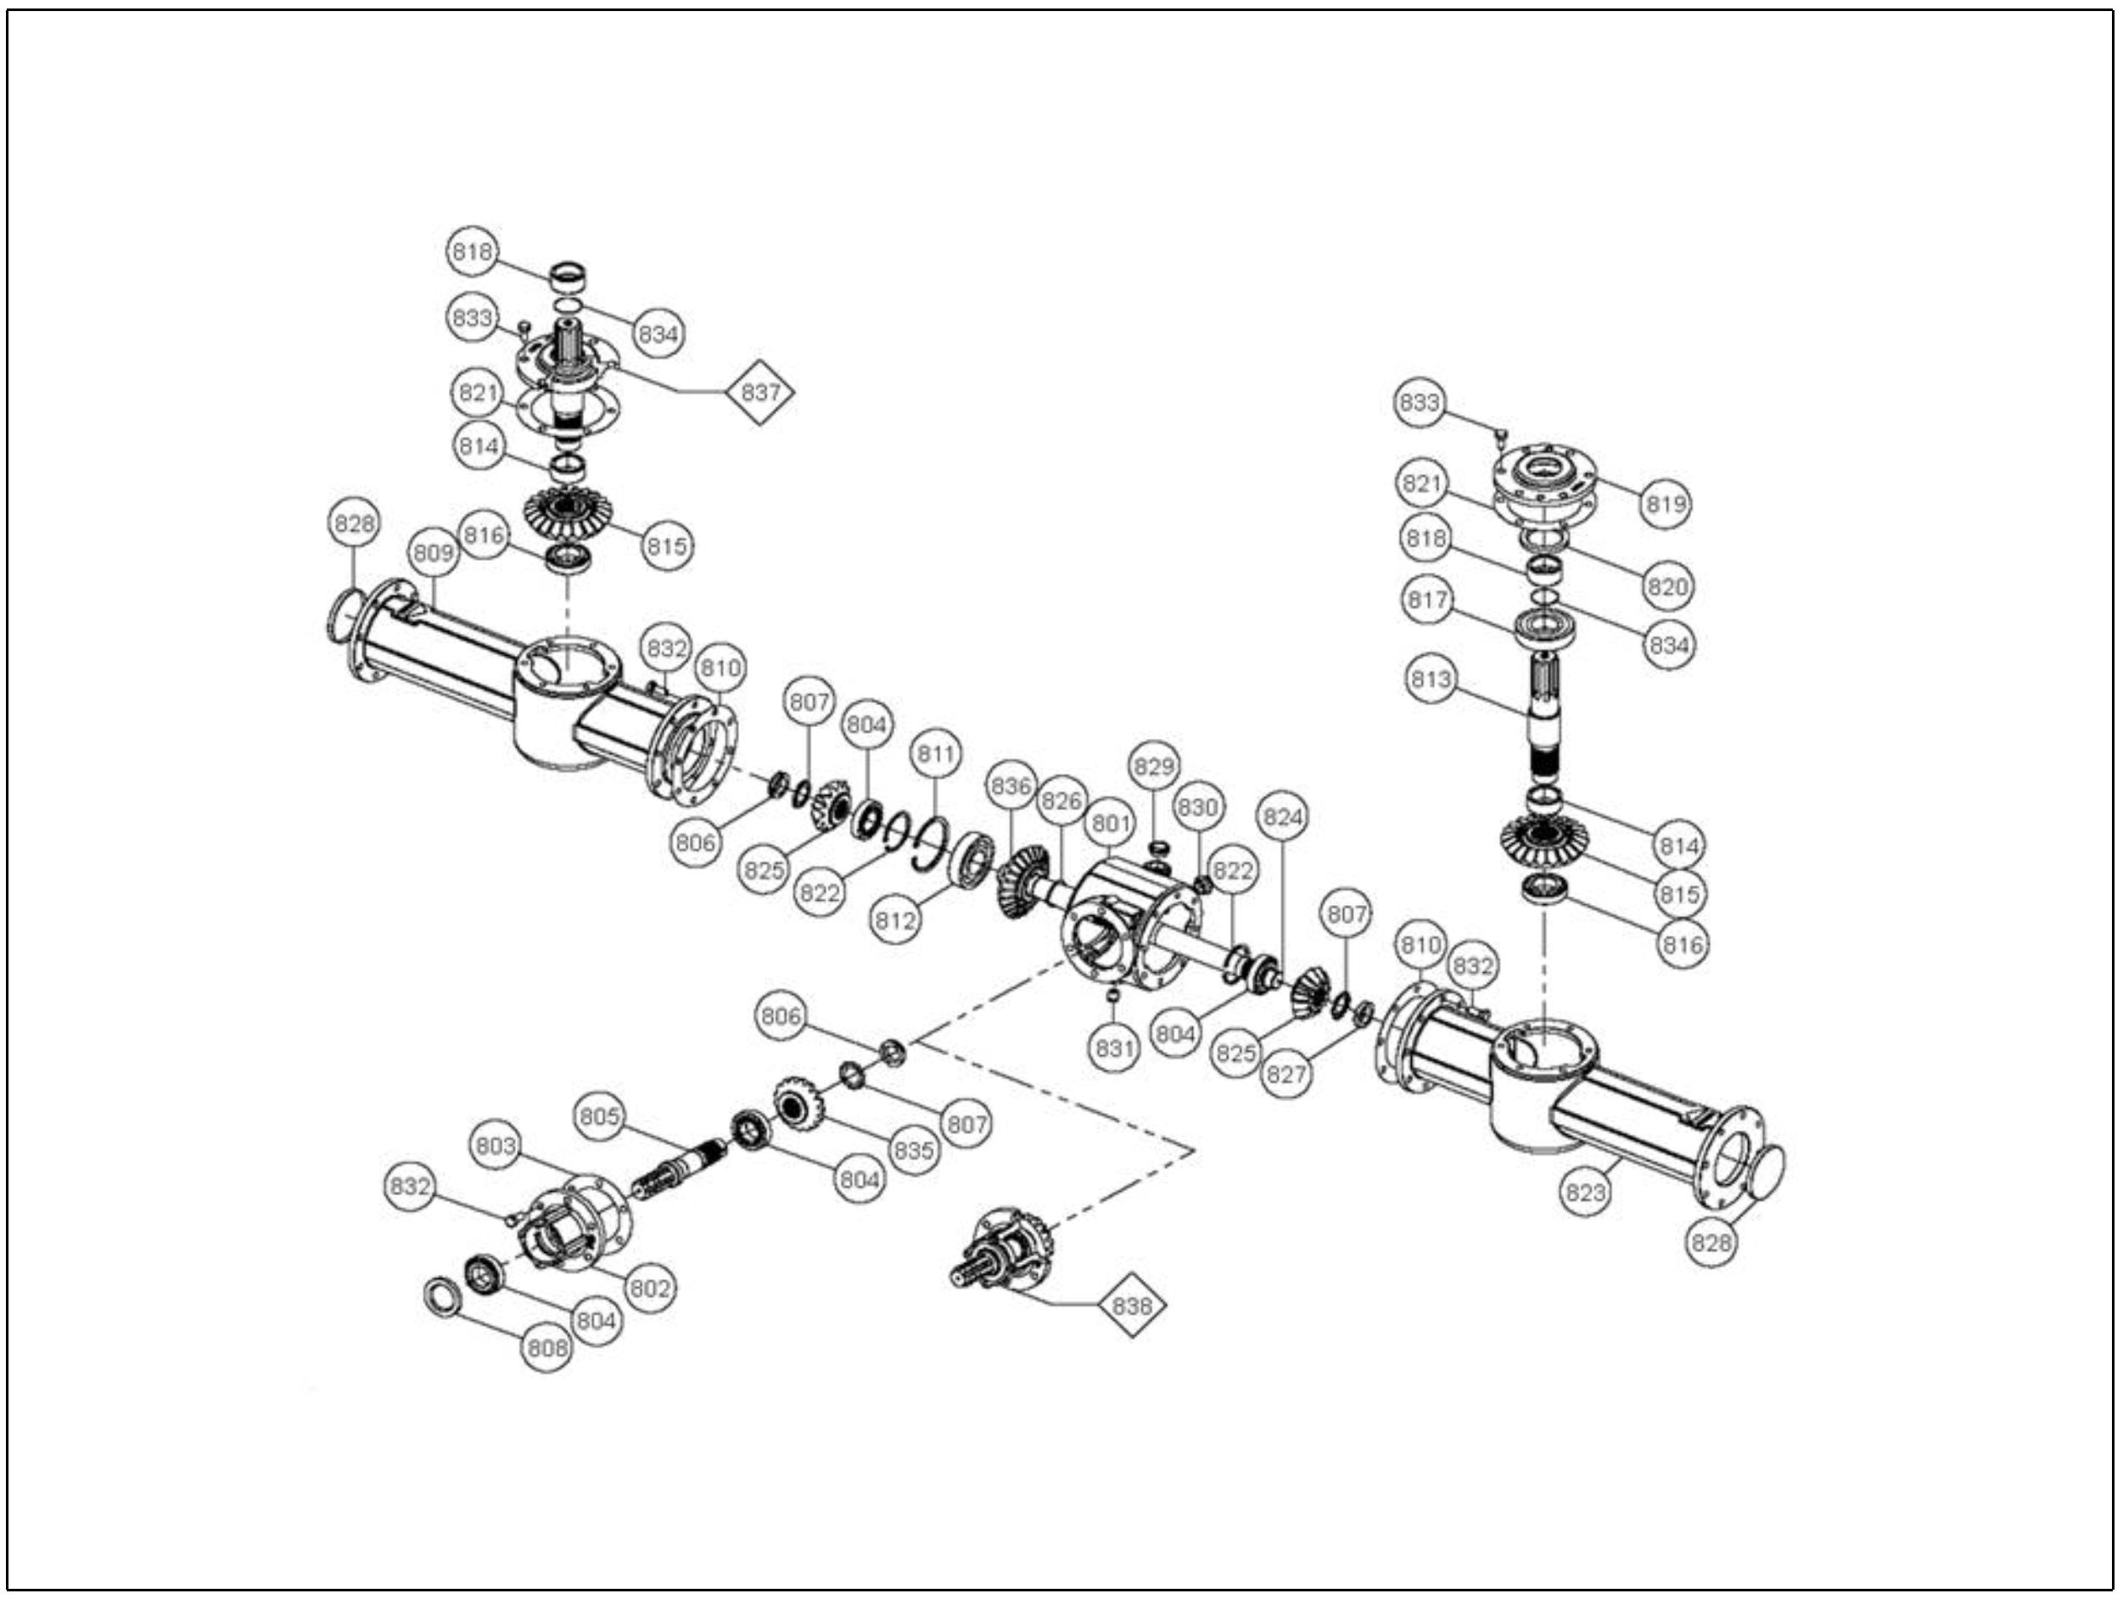

7514-03-01 Hydraulics, Push Off Cylinders
Ref | Part No. | Description | Parts – Assembly | Will Fit SN | Remarks

1 | PR80400 | Hyd. Cylinder, 4 x 144, Main Push Cylinder | 1

2 | PR80401 | Hyd. Cyl. 4 x 57.5 x 2.75, 1st.Push Cylinder | 1

3 | PR80402 | Hyd. Cyl, 4 x 57.5 x 2, Secondary Push Cyl. | 1

600 | A-6801-10 | Elbow, 5/8' MJ x 10 SAE | 6

601 | A-6801-L-10 | Elbow, Long, 5/8' MJ x 10 SAE | 4

602 | A-2403-10 | Union, 5/8' MJ x 5/8' MJ | 1

603 | H-T7027 | Hyd Tube, 5/8', Sliding Floor, 1880 Push | 1

604 | H-T7028 | Hyd Tube, 5/8', Sliding Floor, 1880 Push | 1

605 | H-T7029 | Hyd Tube, 5/8', Pusher Bott, 1880 Push | 1

606 | H-T7030 | Hyd Tube, 5/8', Pusher Bott, 1880 Push | 1

607 | H-T7031 | Hyd Tube, 5/8', Pusher Top, 1880 Push | 1

608 | H-T7032 | Hyd Tube, 5/8', Pusher Top, 1880 Push | 1

609 | H-T7040 | Hyd. Tube, 5/8', Pusher Top, 1880 Push | 1

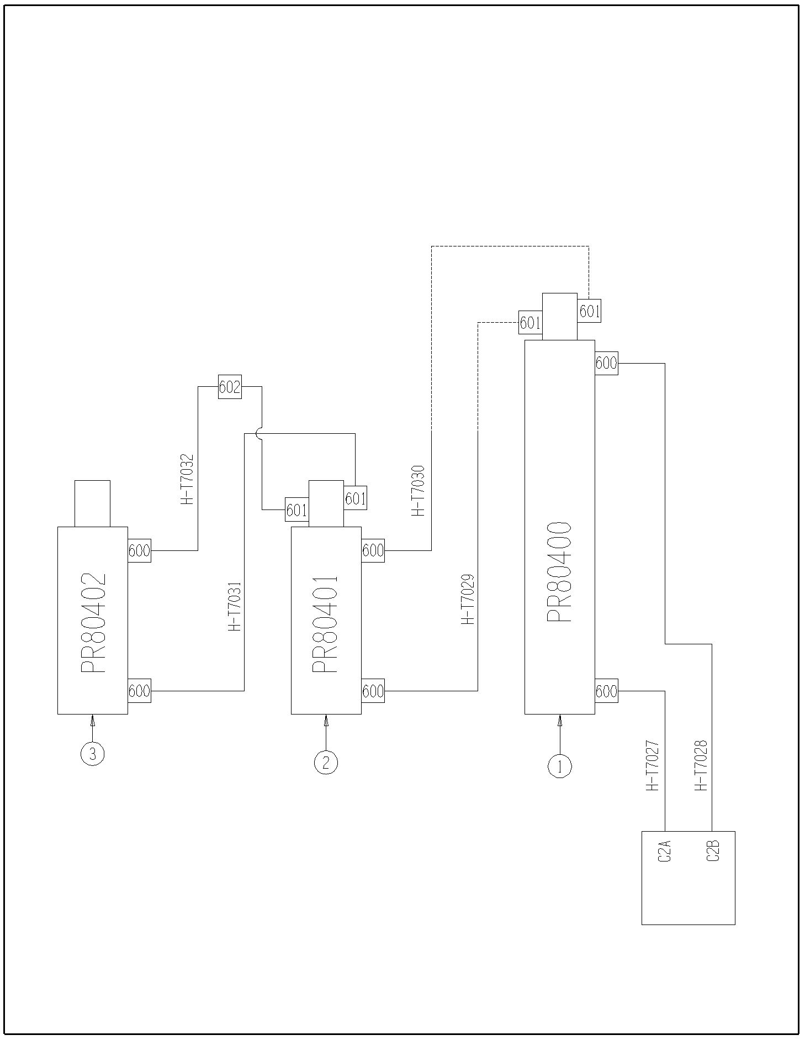
7514-03-01

7514-03-02 Hydraulics, Endgate Clylinders
Ref | Part No. | Description | Parts – Assembly | Will Fit SN | Remarks

600 | HC-250-2408-OR | Hydraulic Cylinder 2 1/2 x 24 #8 SAE w/ O-Piston Ring Seal | 2 |  | NOT TO BE USED IN SINGLE ACTING APPLICATIONS  Replaces HC-250-2408-IV

601 | A-QD2010-8-8 | Tractor Quick Coupler, Male, 1/2' w/ FPT | 2

602 | A-2603-6 | Tee, 3/8' MJ x 3/8' MJ x 3/8' MJ | 2

603 | A-2403-6-6 | Union, 3/8' MJ x 3/8' MJ | 4

604 | A-6901-8-6 | 8 SAE x 3/8' FPX90ｰ, Forged | 4 | 20095001-

610 | H-T7033 | Hyd Tube, 3/8', Endgate, Front, 1880 Push | 1

611 | H-T7034 | Hyd Tube, 3/8', Endgate, Front, 1880 Push | 1

612 | H-T7041 | Hyd Tube, 3/8', Endgate, Back, 1880 Push | 2

613 | H-T7035 | Hyd Tube, 3/8', Endgate, Back, 1880 Push | 1

614 | H-T7036 | Hyd Tube, 3/8', Endgate, Back, 1880 Push | 1

615 | H-T7037 | Hyd Tube, 3/8', Endgate, Right, 1880 Push | 1

616 | H-T7038 | Hyd Tube, 3/8', Endgate, Right, 1880 Push | 1

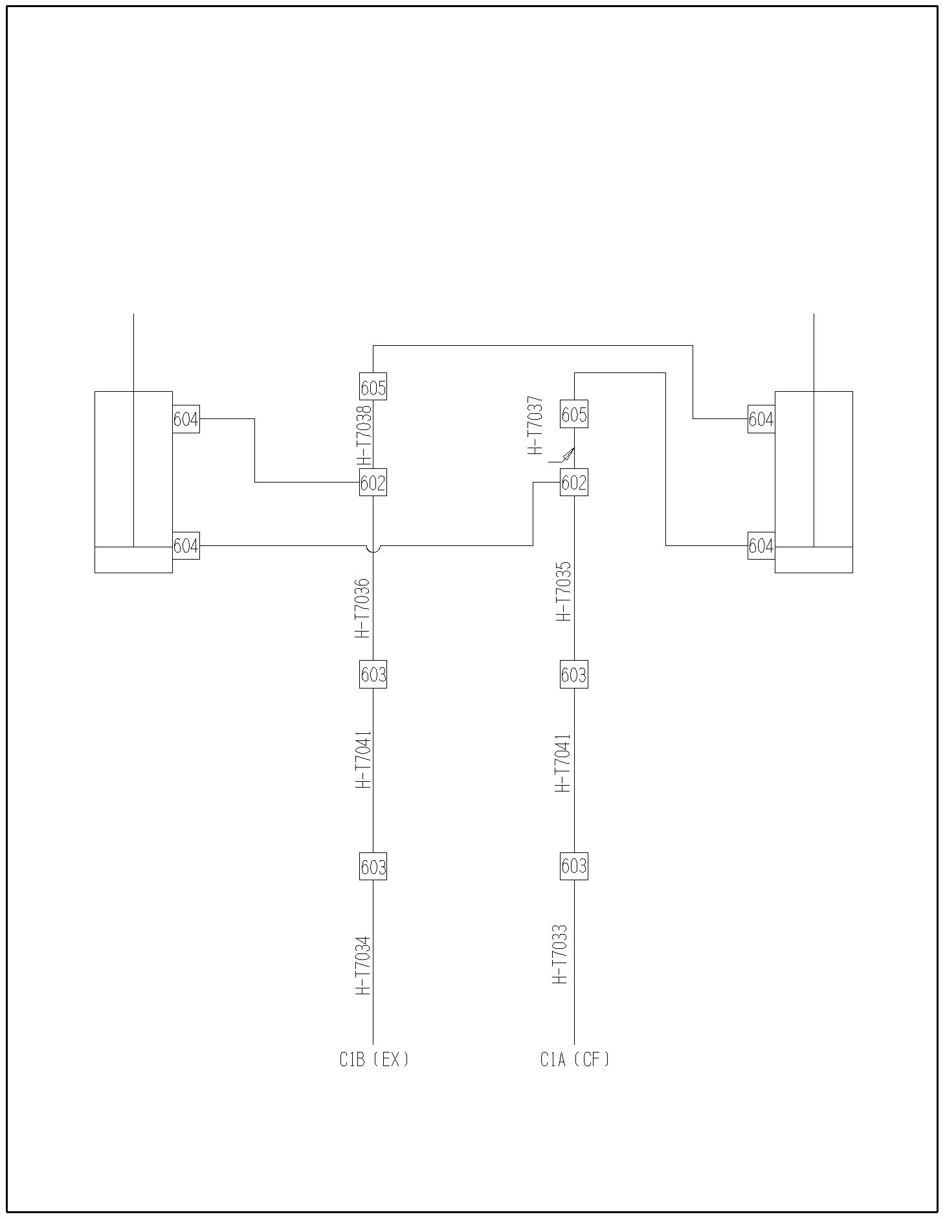
7514-03-02

7514-03-03 Cylinders, Sliding Floor
Ref | Part No. | Description | Parts – Assembly | Will Fit SN | Remarks

 | PR80400 | Hyd. Cylinder, 4 x 144, Main Push Cylinder | 0

800 | PR80401-SK | Seal Kit | 1

801 | PR80401-A | Stover Nut | 1

802 | PR80401-B | Backup Washer | 2

803 | PR80401-C | O-Ring | 1

804 | PR80401-D | Wear Ring | 1

805 | PR80401-E | O-Ring | 1

806 | PR80401-F | Backup Washer | 2

807 | PR80401-G | O-Ring | 1

808 | PR80401-H | O-Ring | 1

809 | PR80401-I | Backup Washer | 1

810 | PR80401-J | Lock Ring | 1

811 | PR80401-K | Bearing Seal | 1

812 | PR80401-L | Wiper | 1

7514-03-04 Cylinders, Main Pusher Cylinder
Ref | Part No. | Description | Parts – Assembly | Will Fit SN | Remarks

 | PR80401 | Hyd. Cyl. 4 x 57.5 x 2.75, 1st.Push Cylinder | 0

800 | PR80401-SK | Seal Kit | 1

801 | PR80401-A | Stover Nut | 1

802 | PR80401-B | Backup Washer | 2

803 | PR80401-C | O-Ring | 1

804 | PR80401-D | Wear Ring | 1

805 | PR80401-E | O-Ring | 1

806 | PR80401-F | Backup Washer | 2

807 | PR80401-G | O-Ring | 1

808 | PR80401-H | O-Ring | 1

809 | PR80401-I | Backup Washer | 1

810 | PR80401-J | Lock Ring | 1

811 | PR80401-K | Bearing Seal | 1

812 | PR80401-L | Wiper | 1

7514-03-05 Cylinder, Secondary Pusher
Ref | Part No. | Description | Parts – Assembly | Will Fit SN | Remarks

 | PR80402 | Hyd. Cyl, 4 x 57.5 x 2, Secondary Push Cyl. | 0

800 | PR80402-SK | Seal Kit | 1

801 | PR80402-A | Stover Nut | 1

802 | PR80402-B | Wear Ring | 1

803 | PR80402-C | O-Ring | 1

804 | PR80402-D | O-Ring | 1

805 | PR80402-E | O-Ring | 1

806 | PR80402-F | Backup Washer | 1

807 | PR80402-G | Lock Ring | 1

808 | PR80402-H | Bearing Seal | 1

809 | PR80402-I | Wiper | 1

7514-03-06 Cylinder, Endgate
Ref | Part No. | Description | Parts – Assembly | Will Fit SN | Remarks

1 | HC-250-2408-OR | Hydraulic Cylinder 2 1/2 x 24 #8 SAE w/ O-Piston Ring Seal | 0 |  | NOT TO BE USED IN SINGLE ACTING APPLICATIONS  Replaces HC-250-2408-IV

801 | HC-250-125 | Seal Kit for 2 1/2' x 1 1/4' Cylinder | 0 | HC-250-3008 (642602, 645596)  HC-250-2408-OR | 2500 or 3000psi cylinders
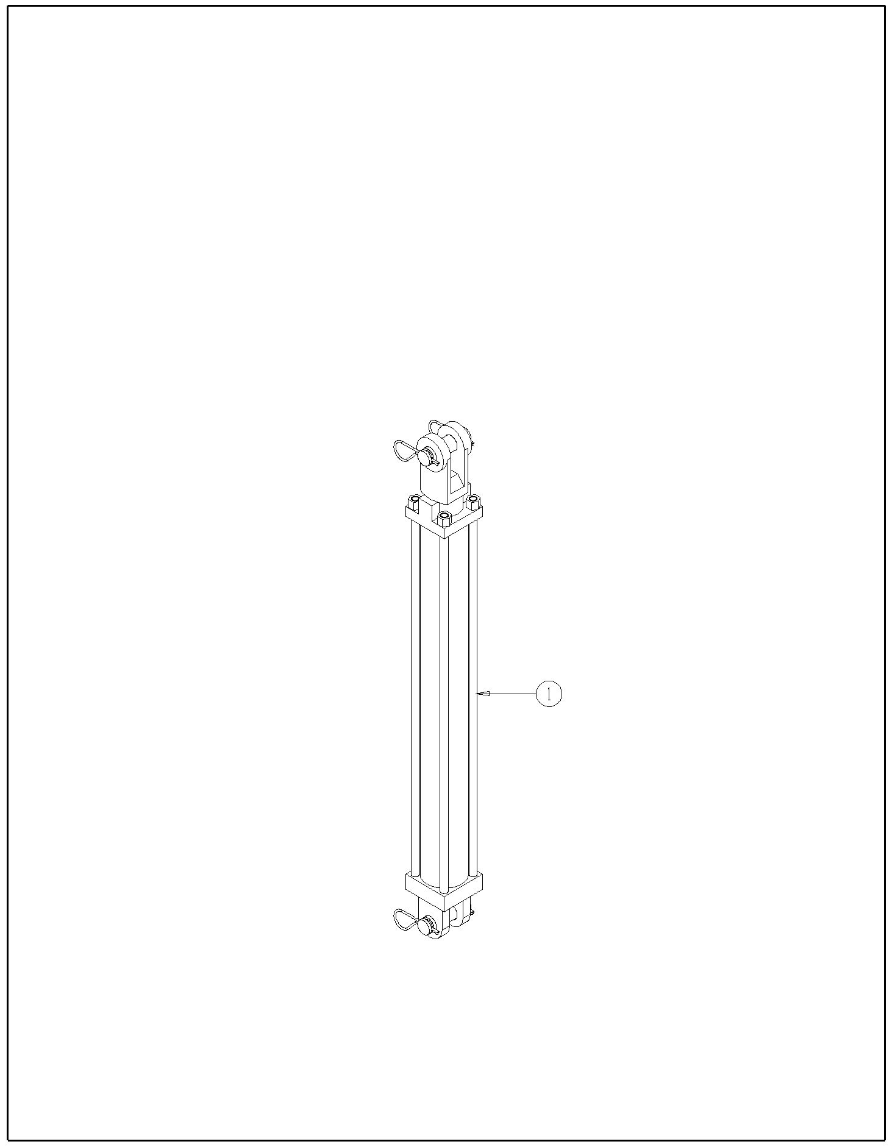
7514-03-06

7514-03-07 Hydraulic, Sequence Valve w/ Flow Control
Ref | Part No. | Description | Parts – Assembly | Will Fit SN | Remarks

1 | HVE-0008 | Sequence Manifold w/Flow control, Spreader Push Cylinders | 1

600 | A-6801-8-8 | Elbow, 1/2' MJ x 8 SAE | 2

601 | A-6900-10-8 | 10 SAE x 1/2 FPX | 2

602 | A-2501-10-10 | 5/8MJIC x 5/8MP 90ｰ | 2

603 | A-6901-8-8 | 8 SAE x 1/2 FPX90ｰ, Forged | 2

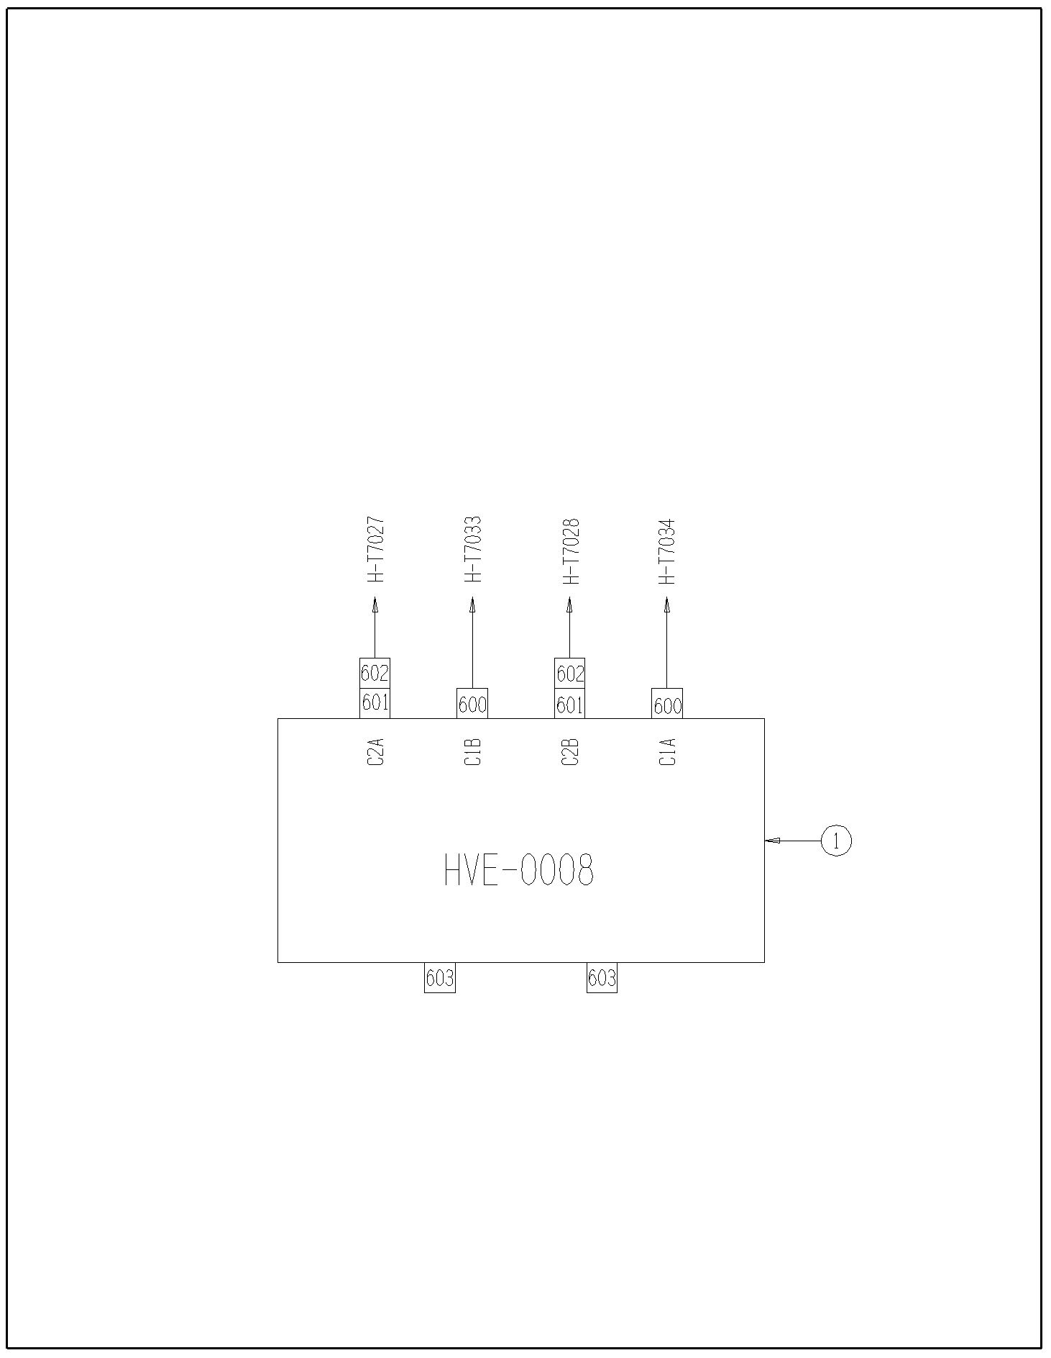
7514-04-01 Air Brakes
7514-03-07

Ref | Part No. | Description | Parts – Assembly | Will Fit SN | Remarks

1 | TRL-BRK-0001 | Trailer Air Brake, Brake Actuating Kit | 1

2 | TRL-BRK-0002 | Air Line Set for Air Brakes | 1

3 | AIR-N6DOT | 3/8' Nylon Tubing @ ft., Meets D.O.T. Specs, Black | 23.875

4 | A-1405-8-8 | 1/2' NPT Coupler W/Swivel | 2

5 | A-1501-12-12 | ｾMP x ｾ FPX 90ｰ | 1

6 | A-1404-12-12 | ｾ MP x ｾ FPX | 1

7 | A-5405-4-6 | Pipe Adapter 3/8 FPT x 1/4 MPT | 2

8 | LA-309 | Universal Gladhand Holder | 2

9 | TRL-BRK-0001-34 | Air Chamber Assembly | 4

10 | PR60032 | Panel, Air Compressor Shield, 880 Spreader | 1

601 | H10-228-12MP-12MP | 5/8 in hose 3/4MP x 3/4MP x 228 in long | 1

801 | TRL-BRK-0003 | Gladhand - Service | 1

802 | TRL-BRK-0004 | Gladhand - Emergency | 1

803 | TRL-BRK-0005 | 1/2' Bulkhead Coupling | 2

804 | TRL-BRK-0006 | 3/8 x 1/4 Male Connector | 2

805 | TRL-BRK-0007 | 3/8 x 3/8 Male Connector | 3

806 | TRL-BRK-0008 | 3/8 x 3/8 Male Elbow | 5

807 | TRL-BRK-0009 | 1/4' Drain Valve | 1

808 | TRL-BRK-0010 | 3/4' Hex Nipple | 1

809 | TRL-BRK-0011 | 3/8' Pipe Plug | 1

810 | TRL-BRK-0012 | Air Tank - Standard 9'x28' | 1

811 | TRL-BRK-0013 | Emergency Spool | 1

812 | TRL-BRK-0014 | Air Relay Valve | 1

814 | TRL-BRK-0016 | 3/8' x 40' Air Brake Hose Assy | 2

815 | TRL-BRK-0017 | 3/8' X 72' Air Brake Hose Assy | 2

816 | TRL-BRK-0001-01 | Beam Options | 1 |  | Special Order Only

817 | TRL-BRK-0001-02 | Spider | 2 |  | Special Order Only

818 | TRL-BRK-0001-03 | Bracket-Camshaft Support | 2 |  | Special Order Only

819 | TRL-BRK-0001-04 | Retainer Plate | 4 |  | Special Order Only

820 | TRL-BRK-0001-05 | Bolt, Retainer Plate Attachment | 8 |  | Special Order Only

821 | TRL-BRK-0001-06 | Lockwasher, Cover Attachment | 8 |  | Special Order Only

822 | TRL-BRK-0001-07 | Nut, Retainer Plate Attachment | 8 |  | Special Order Only

823 | TRL-BRK-0001-08 | Bracket, Air Chamber Mounting | 2 |  | Special Order Only

824 | TRL-BRK-0001-09 | Bushing, Spider Anchor Pin | 4 |  | Special Order Only

825 | TRL-BRK-0001-10 | Anchor Pin | 4 |  | Special Order Only

826 | TRL-BRK-0001-11 | Shoe and Lining Assembly | 4 |  | Special Order Only

827 | TRL-BRK-0001-12 | Lining, Brake Block Cam | 4 |  | Special Order Only

828 | TRL-BRK-0001-13 | Lining, Brake Block Anchor | 4 |  | Special Order Only

829 | TRL-BRK-0001-14 | Roller | 4 |  | Special Order Only

830 | TRL-BRK-0001-15 | Retainer, Roller | 4 |  | Special Order Only

831 | TRL-BRK-0001-16 | Spring, Shoe Retractor | 2 |  | Special Order Only

832 | TRL-BRK-0001-17 | Retainer Pin, Retractor Spring | 4 |  | Special Order Only

833 | TRL-BRK-0001-18 | Spring, Shoe Keeper | 4 |  | Special Order Only

834 | TRL-BRK-0001-19 | Washer, Camshaft | 2 |  | Special Order Only

835 | TRL-BRK-0001-20 | Grease Seal | 4 |  | Special Order Only

836 | TRL-BRK-0001-21 | Bushing, Camshaft Spider | 2 |  | Special Order Only

837 | TRL-BRK-0001-22 | Washer | 2 |  | Special Order Only

838 | TRL-BRK-0001-23 | Washer, Camshaft Slack Adjuster End | 2 |  | Special Order Only

839 | TRL-BRK-0001-24 | Snap Ring | 2 |  | Special Order Only

840 | TRL-BRK-0001-25 | Retainer, Camshaft Slack Adjuster End | 2 |  | Special Order Only

841 | TRL-BRK-0001-26 | Bushing, Camshaft Support | 2 |  | Special Order Only

842 | TRL-BRK-0001-27 | Camshaft, LH/RH | 2 |  | Special Order Only

843 | TRL-BRK-0001-28 | Slack Adjuster Straight Automatic, 1.46 x 28-spline 6' Arm | 2 |  | Special Order Only

844 | TRL-BRK-0001-29 | Nut, Inner Spindle Bearing | 2 |  | Special Order Only

845 | TRL-BRK-0001-30 | Lockwasher, Indexing | 2 |  | Special Order Only

846 | TRL-BRK-0001-31 | Lockwasher, Tab | 2 |  | Special Order Only

847 | TRL-BRK-0001-32 | Nut, Outer Spindle | 2 |  | Special Order Only

848 | TRL-BRK-0001-33 | Grease Fitting, 65ｰ | 2 |  | Special Order Only

850 | TRL-BRK-0001-35 | Lockwasher, Air Chamber Mounting | 4 |  | Special Order Only

851 | TRL-BRK-0001-36 | Nut, Air Chamber Mounting | 4 |  | Special Order Only

852 | TRL-BRK-0001-37 | Sensor Block | 2 |  | Special Order Only

853 | TRL-BRK-0001-38 | Retainer Clip | 2 |  | Special Order Only

854 | TRL-BRK-0001-39 | ABS Sensor, 90ｰ | 2 |  | Special Order Only

855 | A-5502-6-8 | Street Elbow 90, 3/8 MP x 1/2 FP | 2
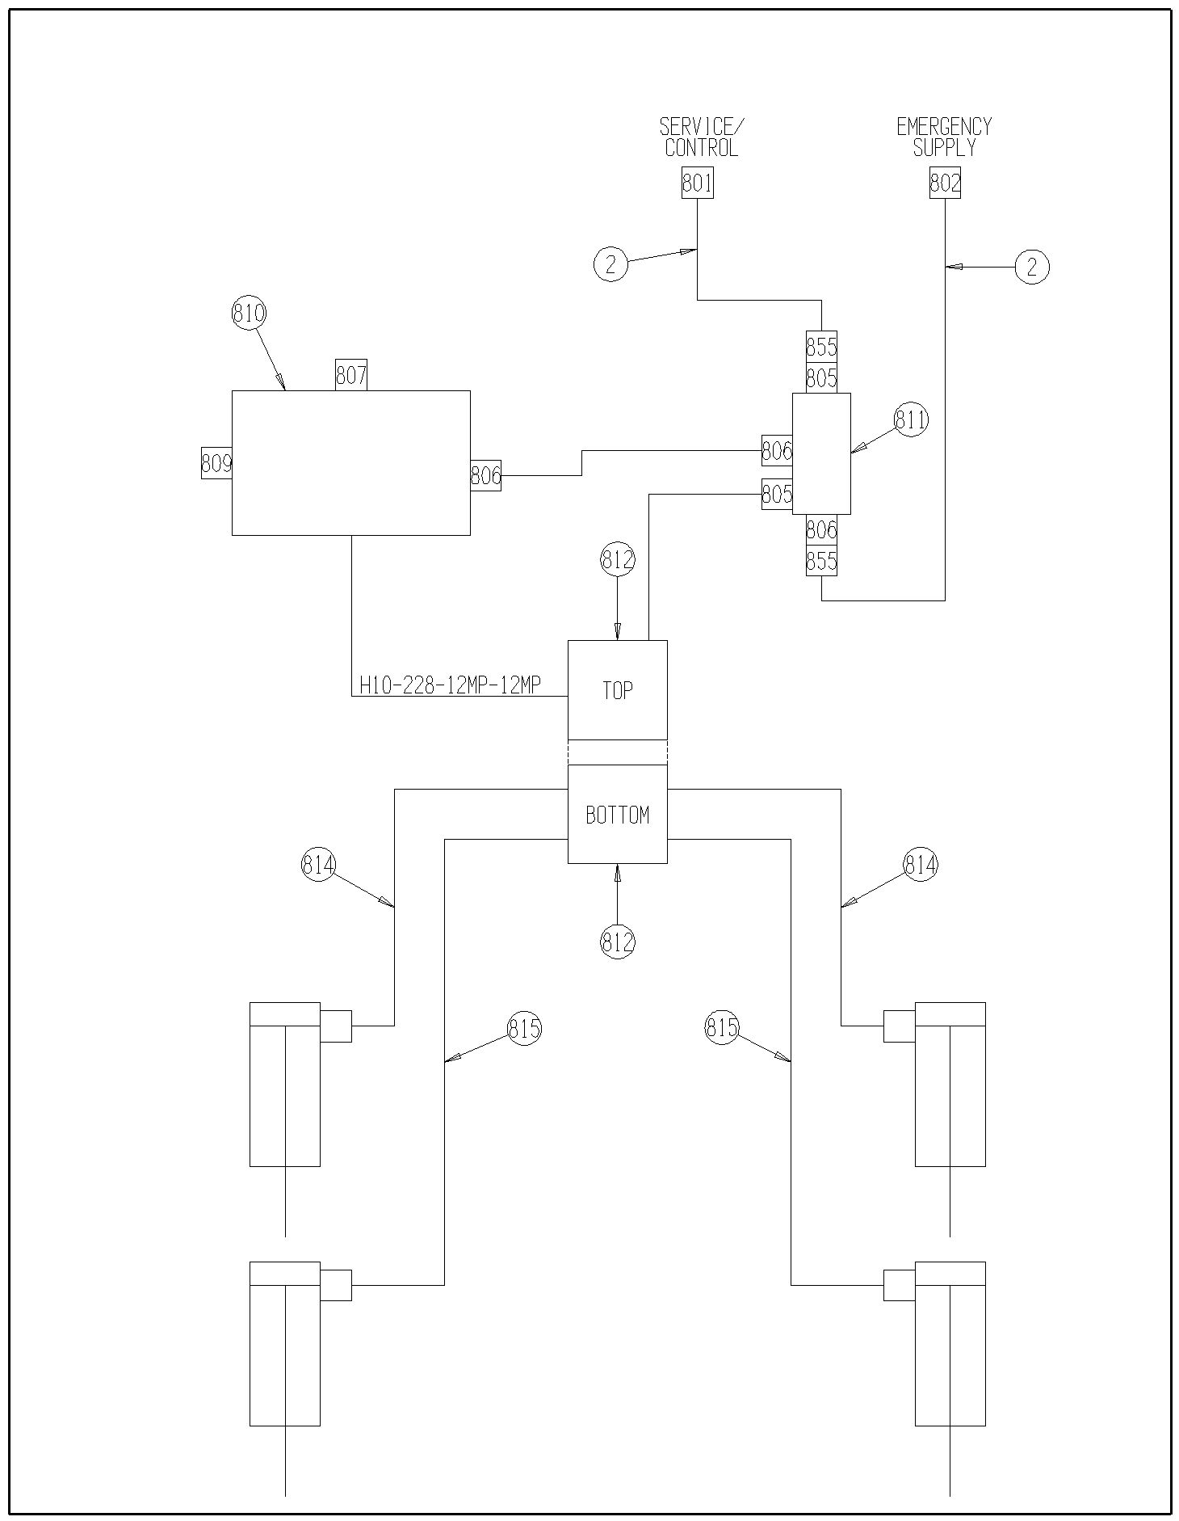
7514-04-02 Hydraulic Brakes
7514-04-01

Ref | Part No. | Description | Parts – Assembly | Will Fit SN | Remarks

1 | PR60074 | Hydraulic Brake Mount, Spreader | 4

2 | H-T7039 | Hyd Tube, 3/8', Hyd Brakes, 1880 Push | 1

3 | H-T7041 | Hyd Tube, 3/8', Endgate, Back, 1880 Push | 1

4 | PR60073 | Spring Return Brake Cylinder, Hyd. Brakes | 4

5 | HV-1002 | Pressure Reducing/Relieving Valve 50-1500 w/RFF Body | 1

6 | HV-1002-K | Standard Knob for HV-1002 | 1

600 | A-2603-6 | Tee, 3/8' MJ x 3/8' MJ x 3/8' MJ | 1

601 | A-1601-6-6-6 | 3/8 MP x 3/8 FPX x 3/8FPX Tee | 3

602 | H4-28-6MP-6MP | 1/4in Hose 3/8MP x 3/8MP x 28 in Long | 2

603 | H4-45-6MP-6FJ | 1/4' x 45' hose, 6MP x 6FJ | 1

604 | H4-40-6MP-6FJ | 1/4' x 40' hose, 6MP x 6FJ | 1

606 | H4-105-6MP-6MP | 1/4 in hose 3/8MP x 3/8MP x 105 in long | 2

607 | H4-33-6MP-6MP | 1/4 hose 3/8MP x 3/8MP x 33' long | 2 | 20095001-

608 | A-1501-6-6 | 3/8' MP x 3/8' FPX90ｰ | 8

609 | A-6901-6-6 | 6 SAE x 3/8' FPX 90ｰ, Forged | 2

610 | A-QD2010-8-8 | Tractor Quick Coupler, Male, 1/2' w/ FPT | 2

611 | A-5404-6-6 | Hex Nipple, 3/8' x 3/8' | 4

612 | HA-1004-T | Test Point Plug, 1/4' NPT | 4

613 | A-1601-04-06-06 | ｼ'MP x3/8'FPX x 3/8'FPX Tee | 4

614 | A-5000-4 | ｼ' NPTF Hex Pipe Cplg. | 4

615 | A-2403-6-6 | Union, 3/8' MJ x 3/8' MJ | 1

616 | A-6801-6 | Elbow, 3/8' MJ x 6 SAE | 1
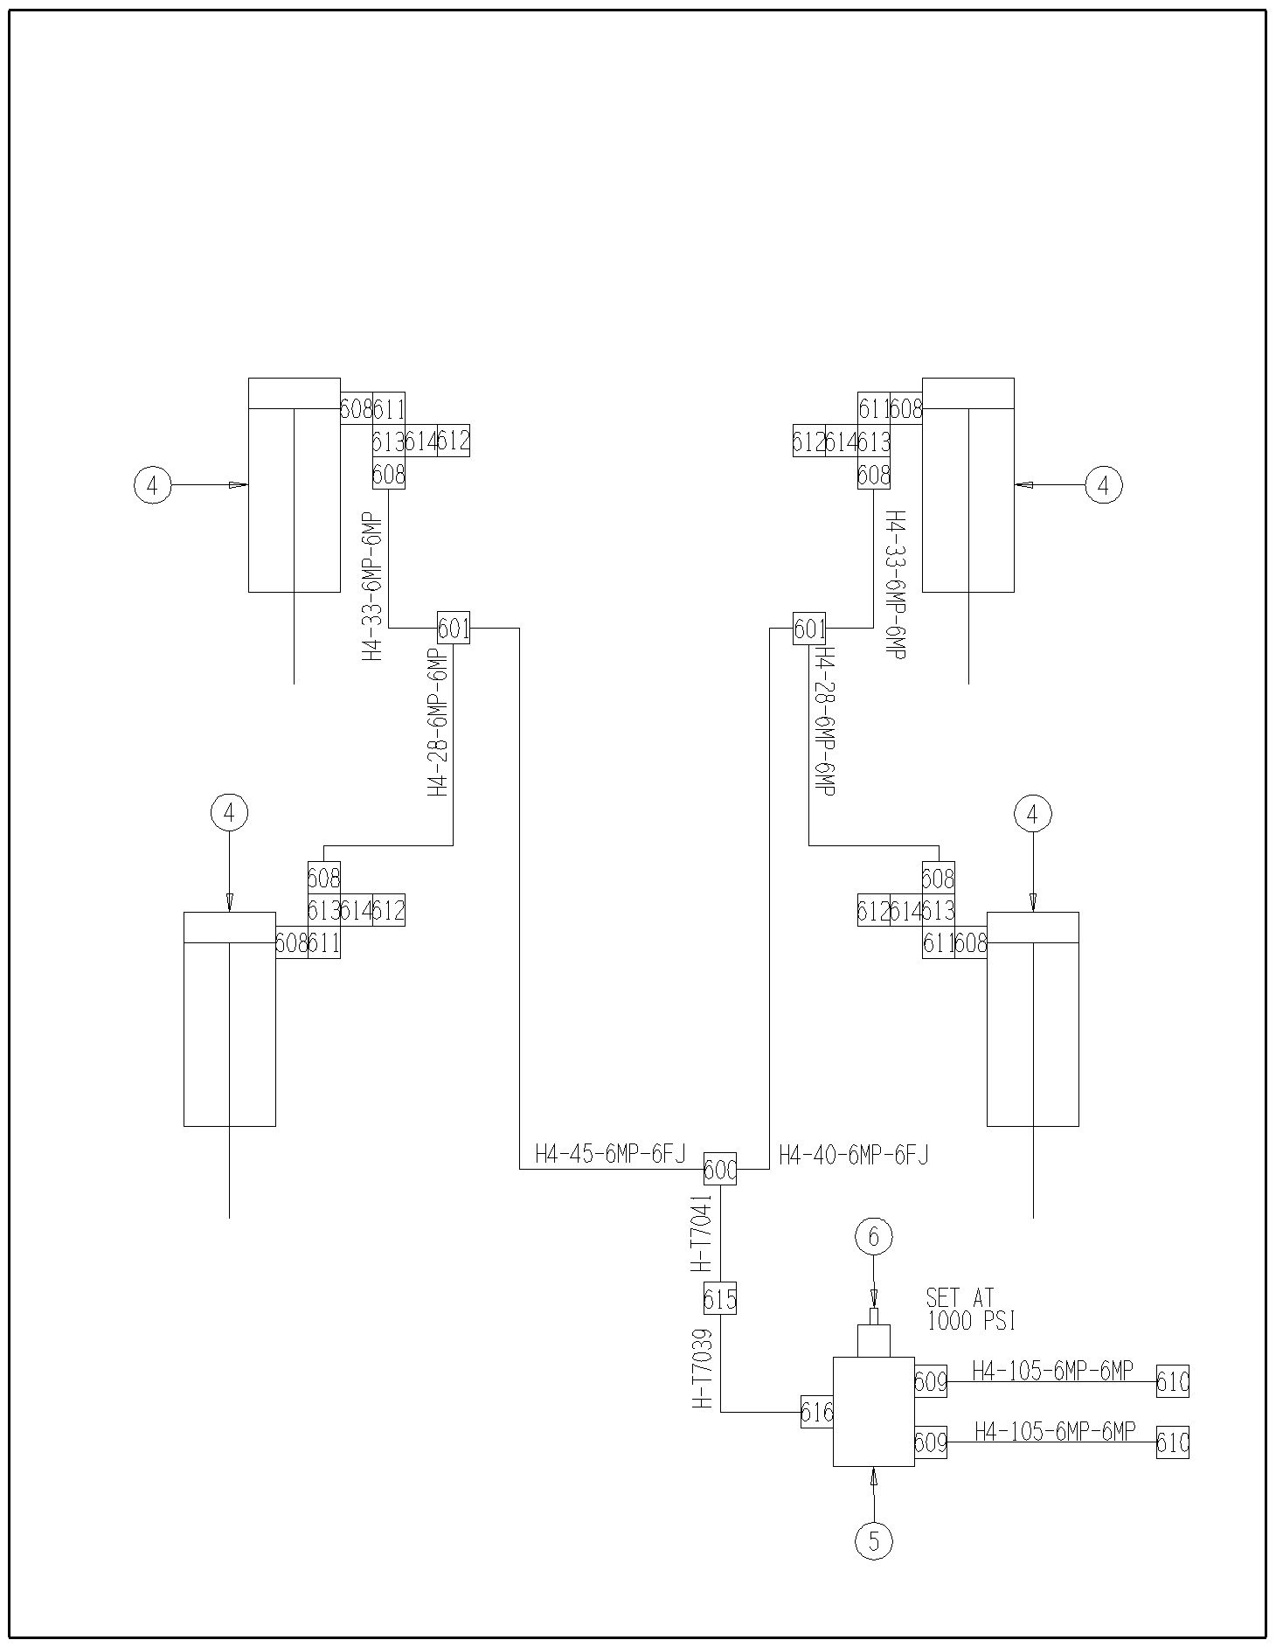
7514-05-01 Electrical & Lighting
7514-04-02

Ref | Part No. | Description | Parts – Assembly | Will Fit SN | Remarks

1 | EL-50561-397 | Spreader Light Harness, Left Side, 1880 Spreader | 1

2 | EL-50562-416 | Light Harness, Right Side, 1880 Spreader | 1

3 | EL-40604-13 | Harness, Work Lights, Spreader | 2

4 | EL-50780-362 | 7 Conductor, 30' Long, Harness, 1880 Spreader | 1

100 | BL-6-125-C | 3/8 UNC X 1 1/4 CARRIAGE BOLT GR5 ZINC | 8

101 | BL-6-LW | 3/8 SPLIT LW ZC | 8

102 | BL-6-N | 3/8-16 HEX NUTS ZC | 8

103 | BL-6-SW | 3/8 SAE FW ZC | 16

104 | BL-6-100-H | 3/8 UNC X 1 HH C/S BOLT GR5 ZINC | 4

105 | BL-6-LN | 3/8 UNC FIN HEX LOCK NUT NE A563 GrA ZINC | 4

106 | BL-1224-125-DT | 12-24 x 1 1/4' Drill and Tap Screw | 6

107 | BL-4-FW-8 | 1/4' Flat Washer Grade 8 | 10

108 | HA-1031 | Hydraulic Hose Holder 3/8 | 6

109 | BL-4-075-H | 1/4 UNC X ｾ HH C/S BOLT GR5 ZINC | 2

110 | BL-4-LN | 1/4-20 HEX LN NE ZC | 2

111 | ELL-375 | 3/8' Wire Loom @ft | 2

601 | EL-1233 | Light, Auxiliary Work Light, Clear, Trapezoid Beam, TL#80394 | 2 |  | Replaces EL-1201

602 | EL-1297 | Light, Aux/Turn, L.E.D., TL60, Yellow | 4

603 | EL-12571 | Light, STT, L.E.D., TL60, Red, | 2

604 | ELE-15-964 | Junction Box, 4x8x3.5deep, plastic, w/knockouts & plugs | 1 | 19426

605 | ELT-37675 | Seven Conductor Plug with Spring, Round Connection | 1 | Trucks

606 | PR19480 | Light Housing, LH | 1

607 | PR19481 | Light Housing, RH | 1

609 | EL-1279 | Grommet, TL60, Oval, TL#60700 | 6

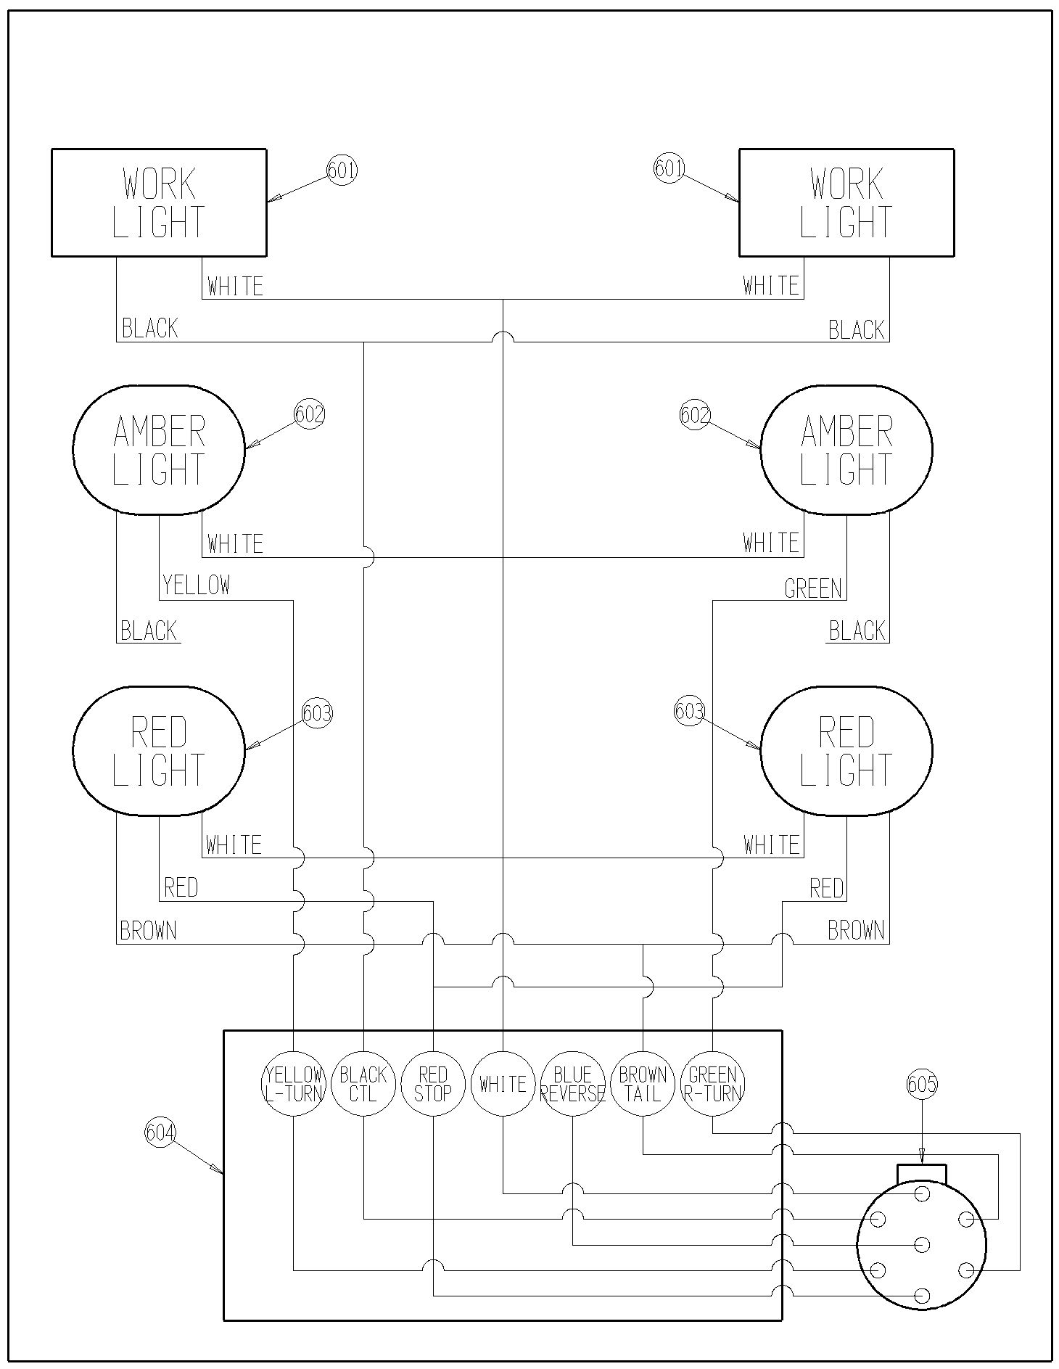
7514-05-01

7514-05-02 Safety Tow Chain
Ref | Part No. | Description | Parts – Assembly | Will Fit SN | Remarks

1 | FRM-3172 | Safety Chain, Agricultural, 60,600 lb. Capacity | 1

101 | BL-24-FW | 1 1/2' Flat Washer, Zinc | 1

102 | BL-16-FW | 1' Flat Washer, Zinc | 2

103 | BL-16-500-H | 1 UNC x 5 HH C/S GR5 ZINC | 1

104 | BL-16-LN | 1' Lock Nuts w/ Nylon Inserts | 1

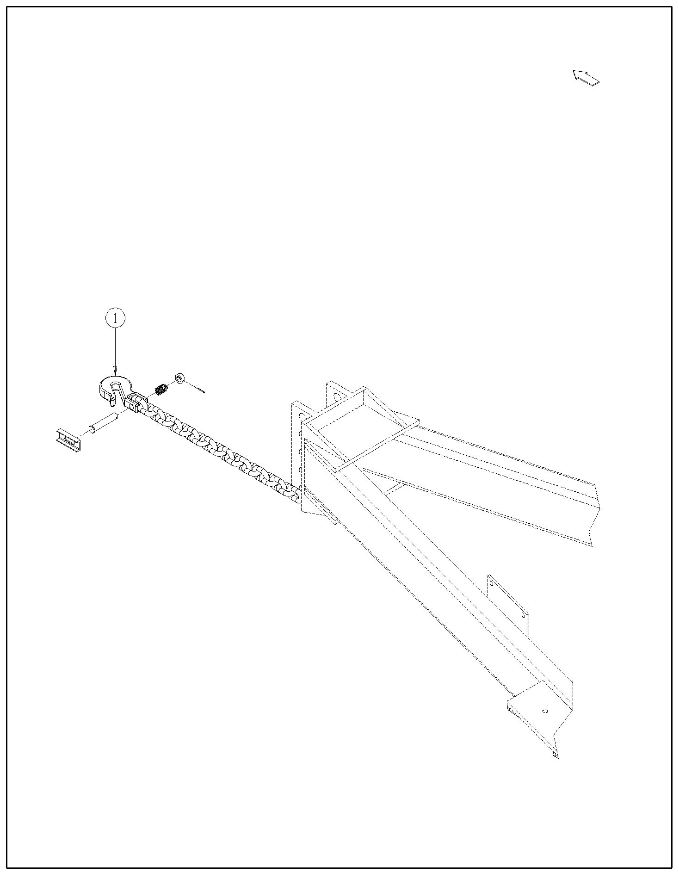
7514-05-03 Jack Stand
7514-05-02

Ref | Part No. | Description | Parts – Assembly | Will Fit SN | Remarks

1 | WH-1131 | Jack, 1880 Spreader | 1

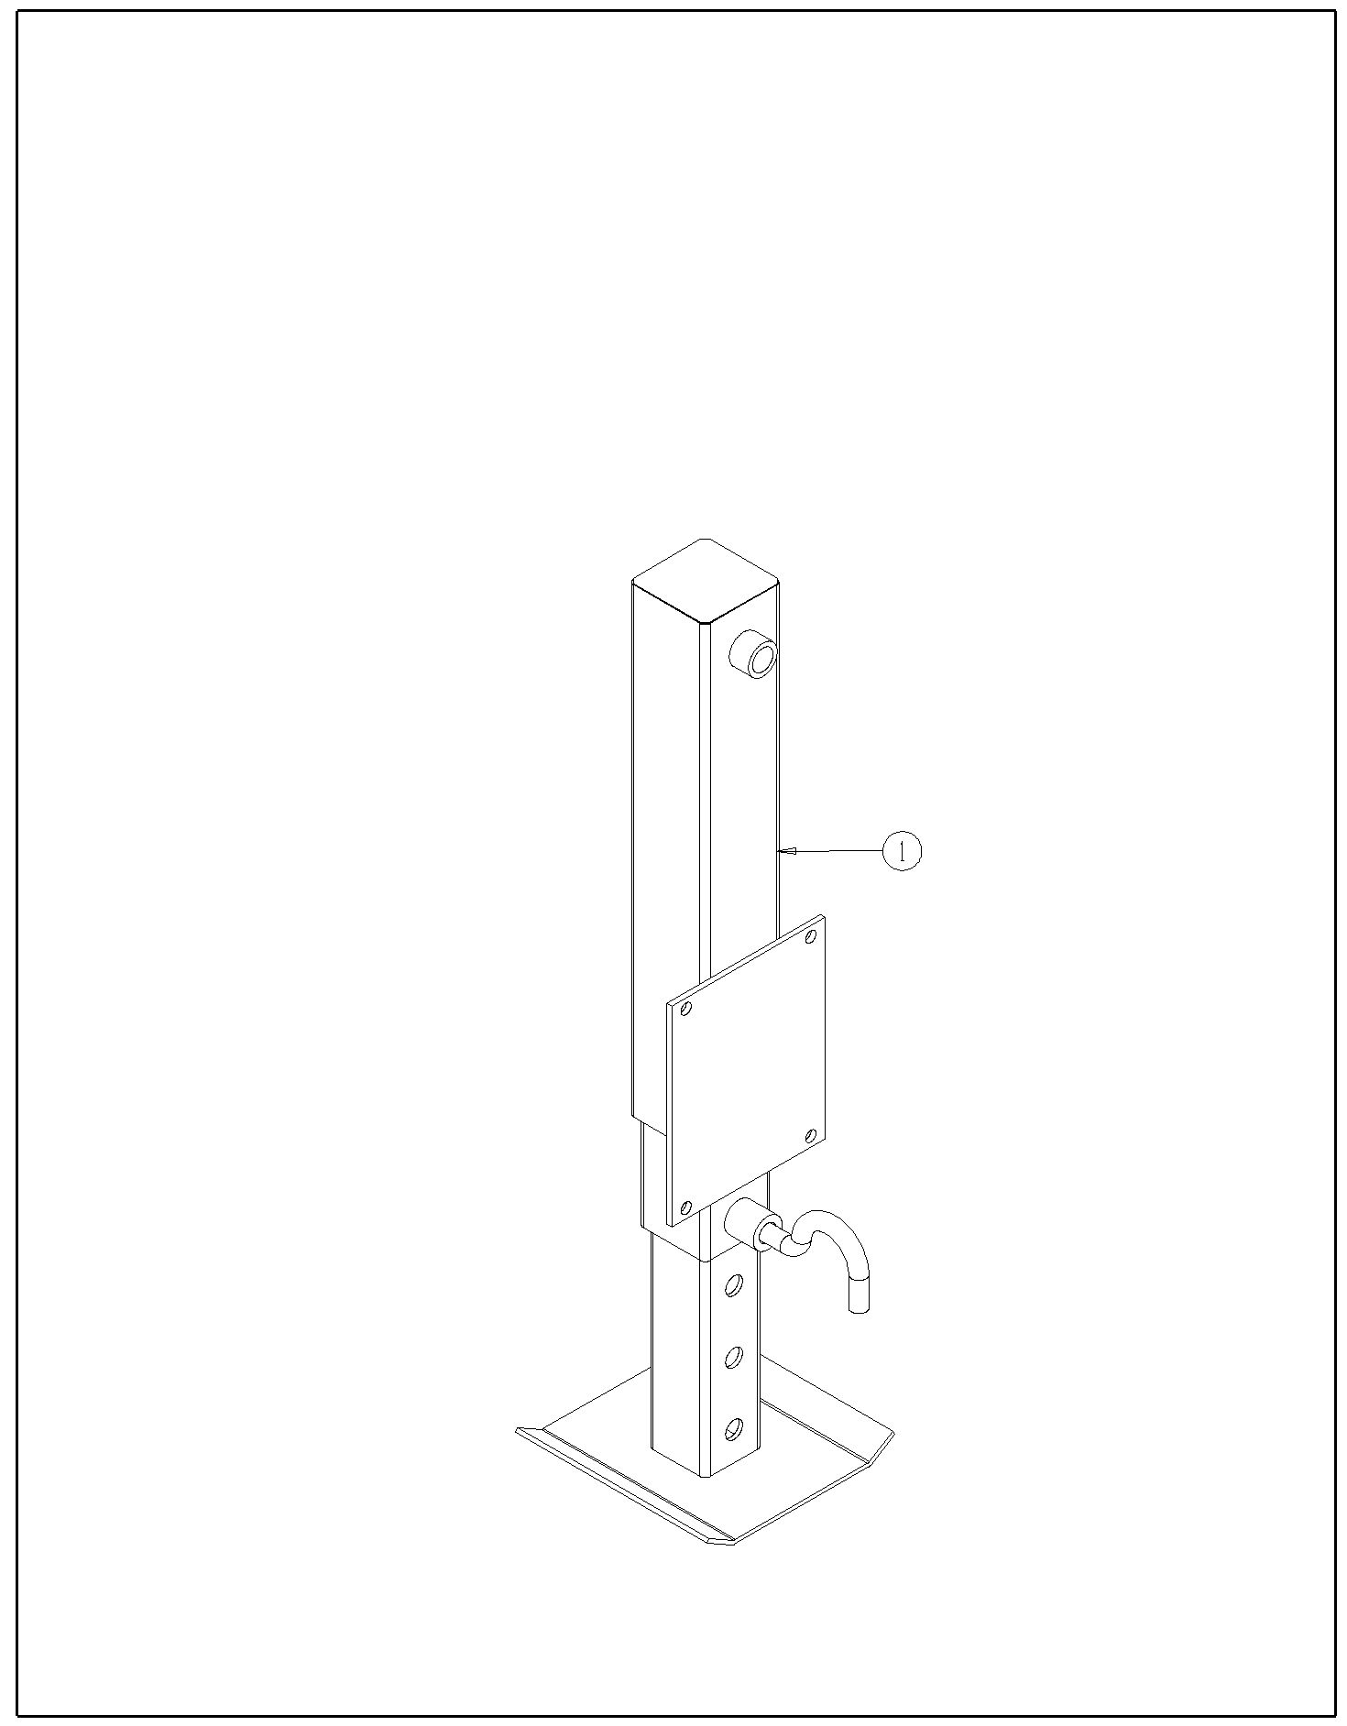
7514-05-03

7514-05-04 SMV Emblem & Brackets
Ref | Part No. | Description | Parts – Assembly | Will Fit SN | Remarks

1 | SMV-PL | SMV Sign, Metal | 1

2 | SMV-S | Socket for Spade Mount | 1

3 | SMV-SM | Spade Mount | 1

4 | PR39117 | Bracket, SMV Sign, Spreader | 1

101 | BL-5-075-H | 5/16-18 X ｾ HEX CAP G5 ZC | 2

102 | BL-4-062-C | 1/4' x 5/8' Zinc Carriage Bolt | 2

103 | BL-5-LN | 5/16-18 HEX LN NE ZC | 2

104 | BL-4-LN | 1/4-20 HEX LN NE ZC | 2

105 | BL-5-FW | 5/16 USS FW ZC | 2

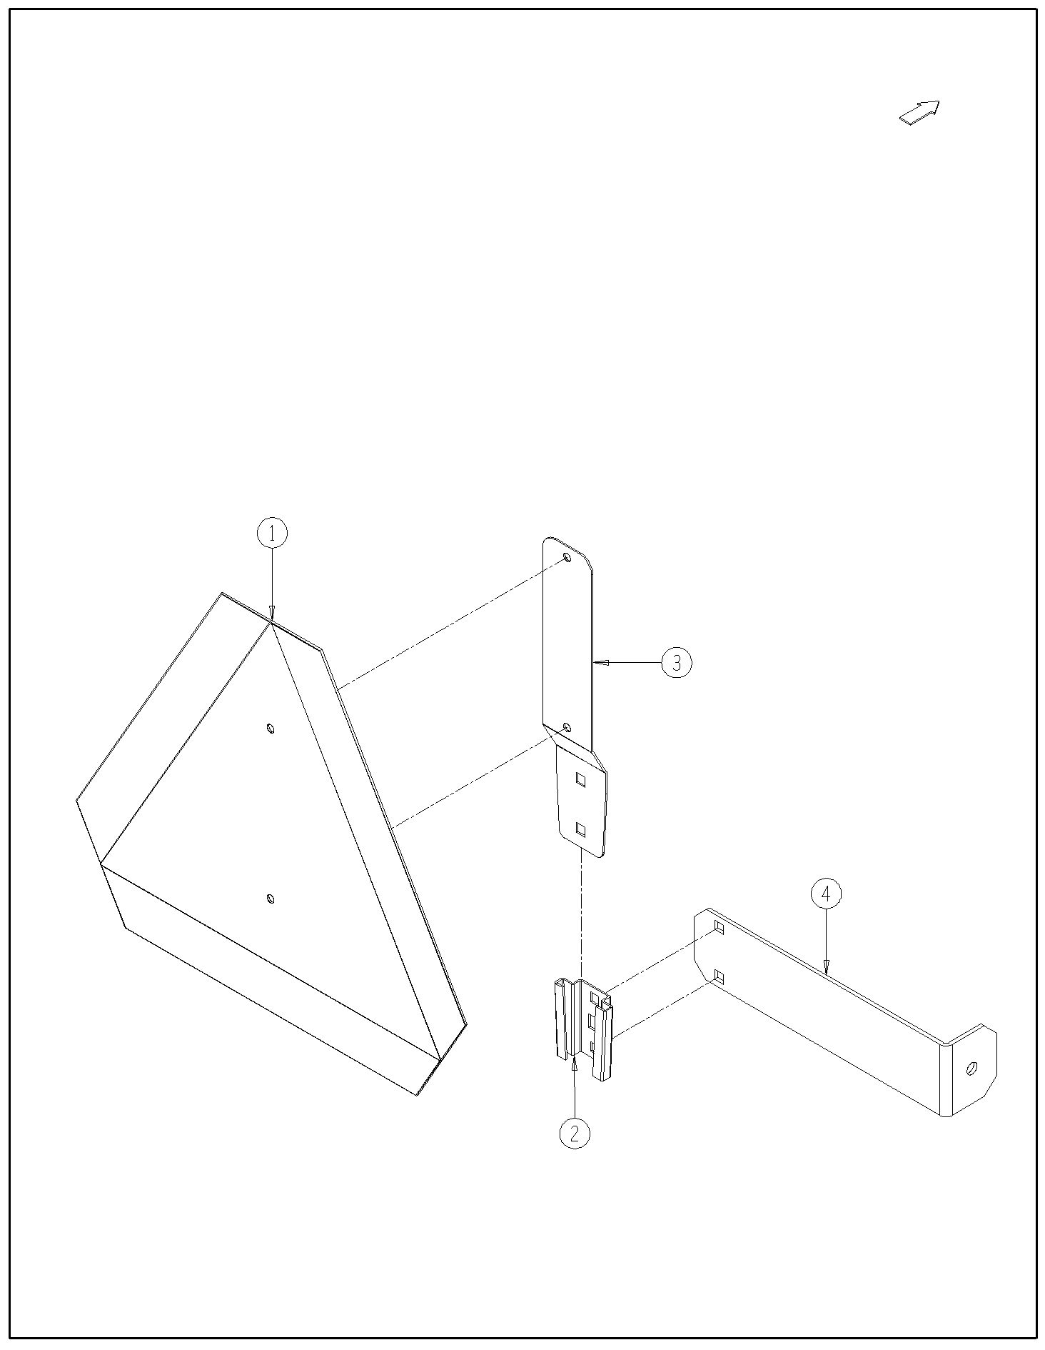
7514-06-01 Decals, Front of Spreader
7514-05-04

Ref | Part No. | Description | Parts – Assembly | Will Fit SN | Remarks

1 | DC-0011 | Decal, All, 'Made in USA', White Back w/ Red & Blue Letters | 1

2 | DC-0021 | Decal, Caution, 1000 rpm PTO | 1

3 | DC-0022 | Decal, Tractor Drawbar Adjustments | 1

4 | DC-0023 | Decal, Caution, Keep All Shields In Place | 1

5 | DC-0025 | Decal, Danger, Entanglement In Rotating Drive | 2

6 | DC-0034 | Decal, Amber, Reflector, Spreader | 2 |  | ** Replace with EL-1226 ** Do Not Order

7 | DC-0082 | Decal, Hydra-Pull, Large, Front & Side Panels | 1

8 | DC-1174 | Decal, Danger Keep Hands and Feet Away | 2

101 | RI-3-6-P | Pop Rivets 3/16 x 3/8 Domed, .375 head, ea. | 2

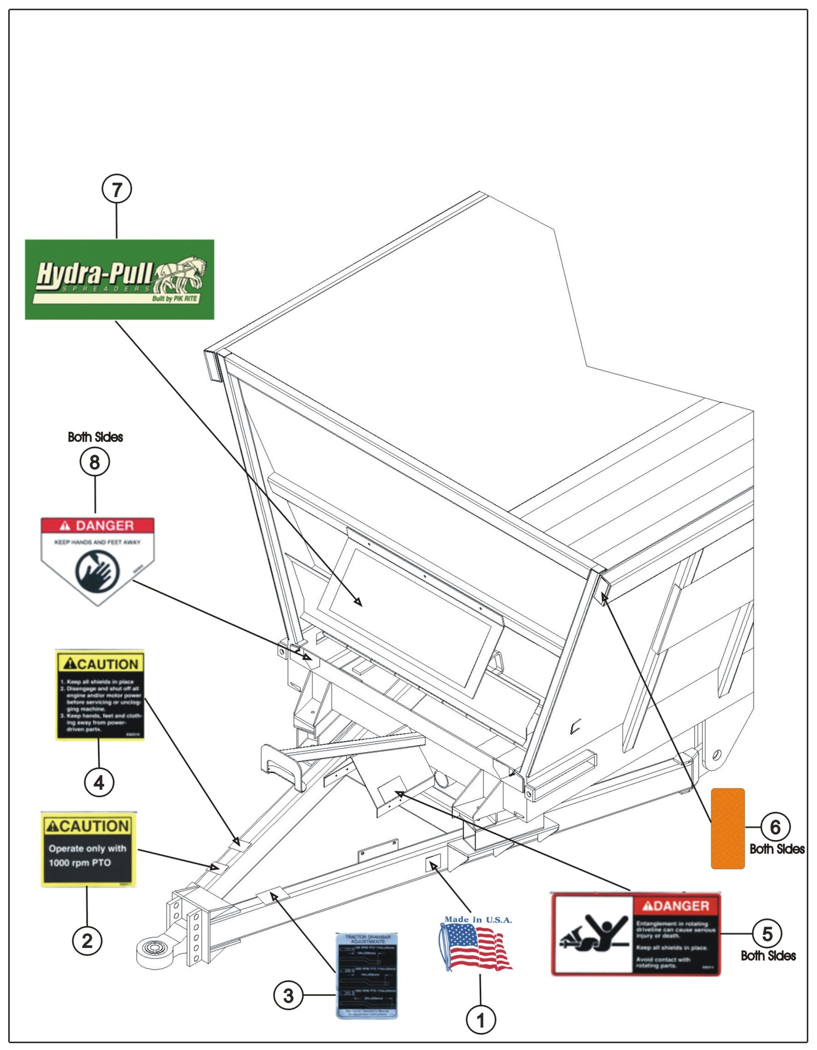
7514-06-01

7514-06-02 Decals, Side & Rear
Ref | Part No. | Description | Parts – Assembly | Will Fit SN | Remarks

1 | DC-0025 | Decal, Danger, Entanglement In Rotating Drive | 2

2 | DC-0026 | Decal, Warning, Crushing Under Endgate | 4

3 | DC-0030 | Decal, Danger, Entanglement In Beater | 2

4 | DC-0033 | Decal, Red, Reflector, Spreader | 2

5 | DC-0034 | Decal, Amber, Reflector, Spreader | 2 |  | ** Replace with EL-1226 ** Do Not Order

6 | DC-0038 | Decal, Caution, Raise Endgate Completely | 2

7 | DC-0082 | Decal, Hydra-Pull, Large, Front & Side Panels | 2

8 | DC-0083 | Decal, 1880vb, Model # | 2

9 | DC-4W | Decal, Logo, White, 5.25' Long, Tanks, 1/29/99 | 2

10 | DC-3025 | Red and White Reflective Tape @ 150 ft Roll | 0.14667

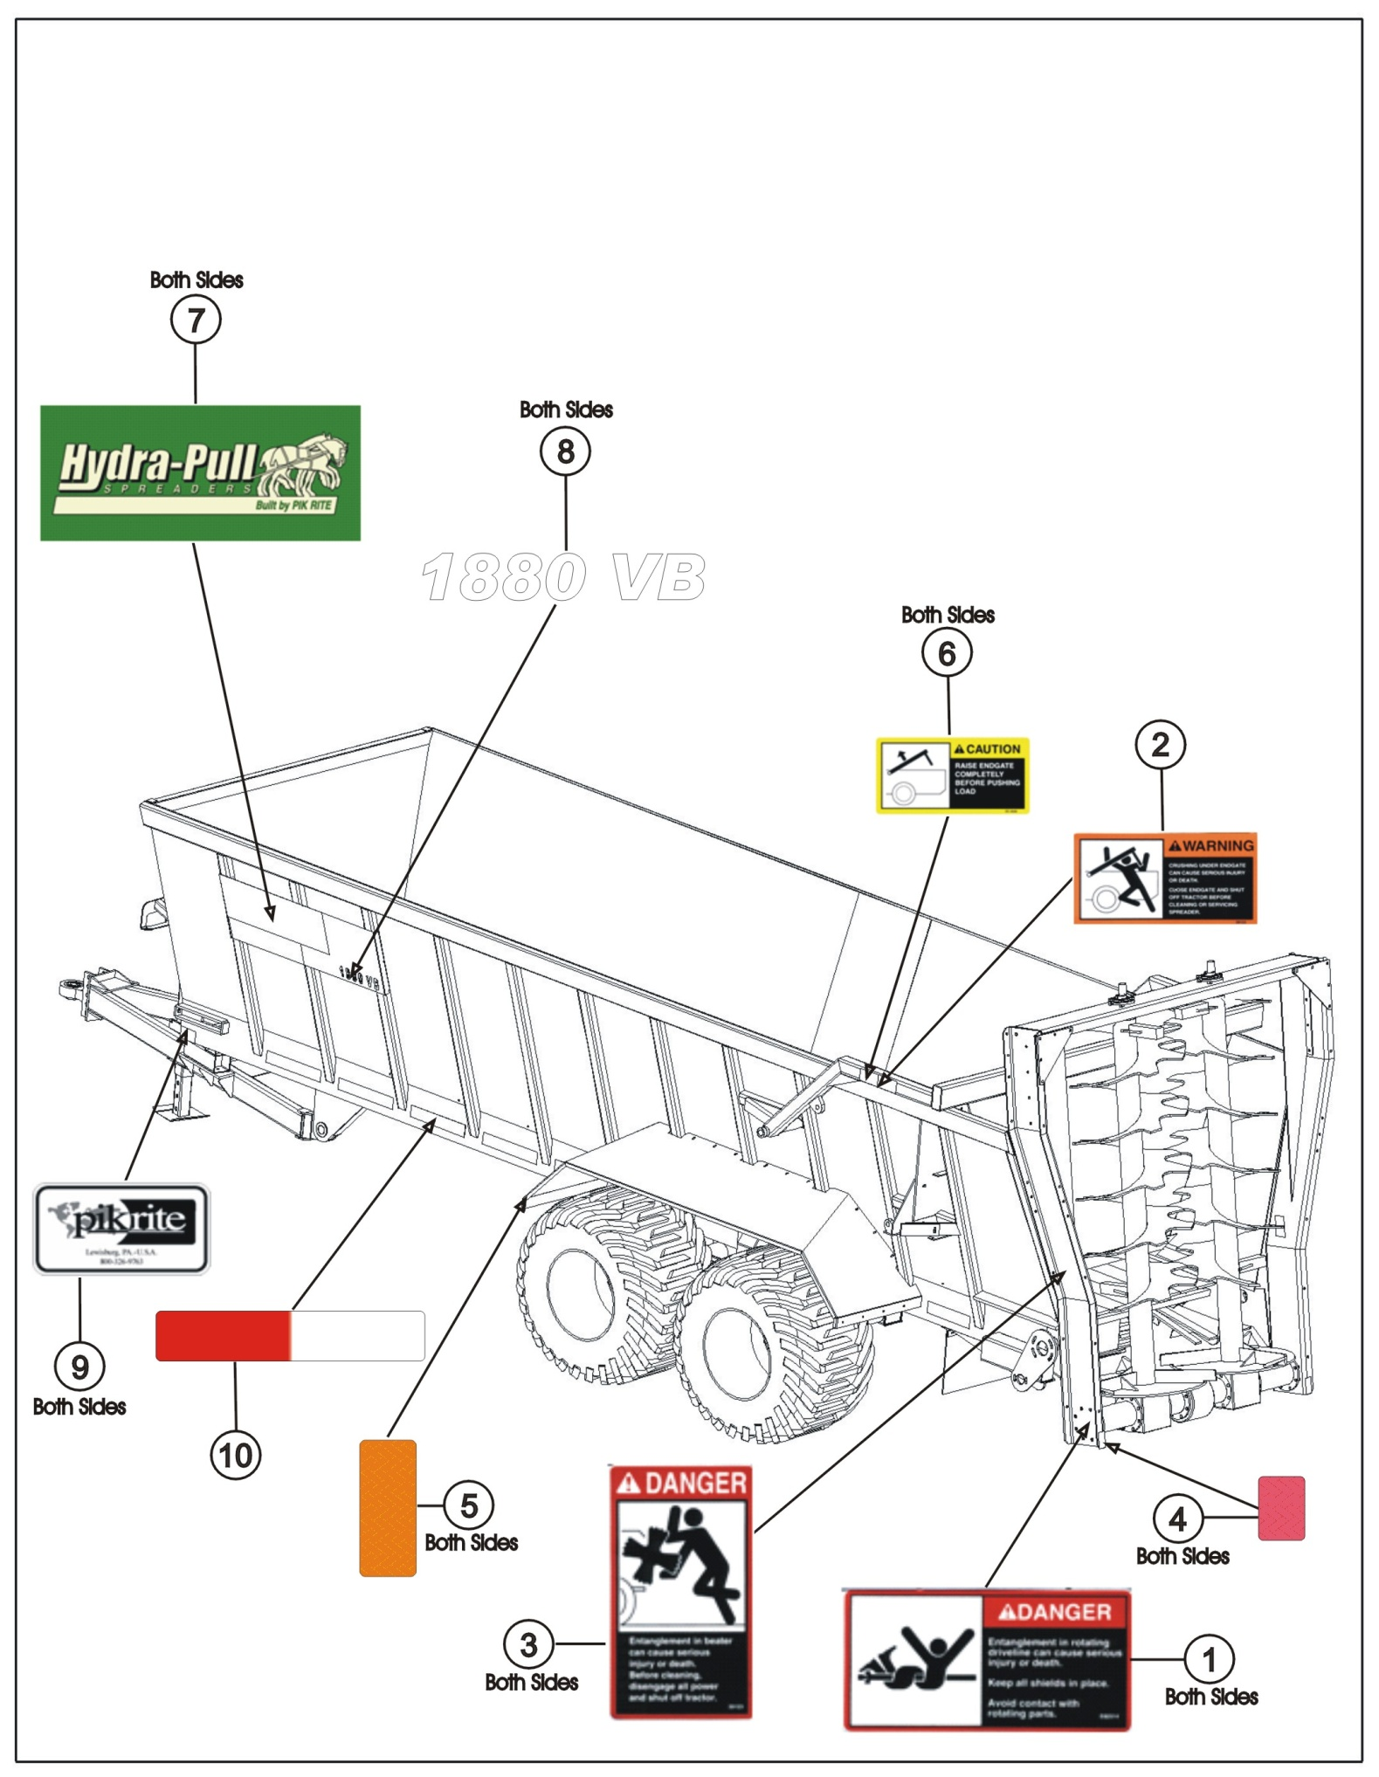
7514-06-02

